**Using Google Cloud Platform IAM service account with gcloud**

**Contents**

* [Overview](https://qa-community.co.uk/~/_/learning/lbg-gcp/gcp--iam-service-account-gcloud#overview)
* [Tutorial](https://qa-community.co.uk/~/_/learning/lbg-gcp/gcp--iam-service-account-gcloud#tutorial)
* [Exercises](https://qa-community.co.uk/~/_/learning/lbg-gcp/gcp--iam-service-account-gcloud#exercises)

**Overview**

Usually when you are using SDK gcloud command line tool from a shell, you use your personal GCP user SSO account. For example user John Doe registered in Google SSO (like Google Workspaces) for company domain yourcompany.com is very likely to be logged into GCP as john.doe@yourcompany.com. So if John executes the gcloud auth list command, he should see an output similar to:

$ gcloud auth list

Credentialed Accounts

ACTIVE ACCOUNT

* john.doe@yourcompany.com

**To** set the active account, run:

$ gcloud config set account `ACCOUNT`

This is exactly what we expected, because all actions performed by John using gcloud command should be executed on his behalf.

However what if John set up an IAM service account named jenkins@hktest-329511.iam.gserviceaccount.com (with a permission to push images into GCP Container Registry) that John would like to use on Jenkins server, so Jenkins can build and push Docker images? The tutorial below will show you how to use gcloud together with service accounts instead of your named credentials.

Before you start our tutorial, make sure you:

* understand how service accounts work
* understand how to generate a JSON credentials file for a service account
* created IAM service account (ideally named jenkins)
* assigned Storage Admin role to it (so it can push images into GCP Container Registry)

**Tutorial**

First of all, generate JSON credentials file for the service account of your choice.

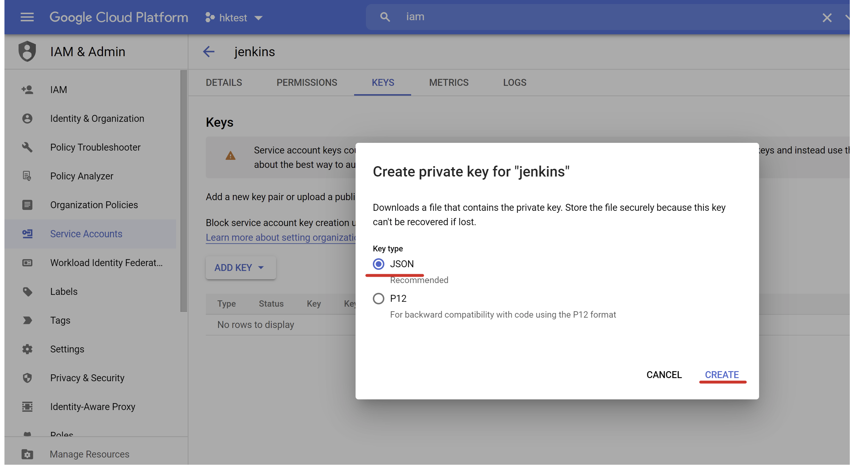

Your web browser should download service account key to your desktop. Keep in mind that this is secret file and anybody who got access to it can use it to access your GCP resources. Keep it safe and secure!

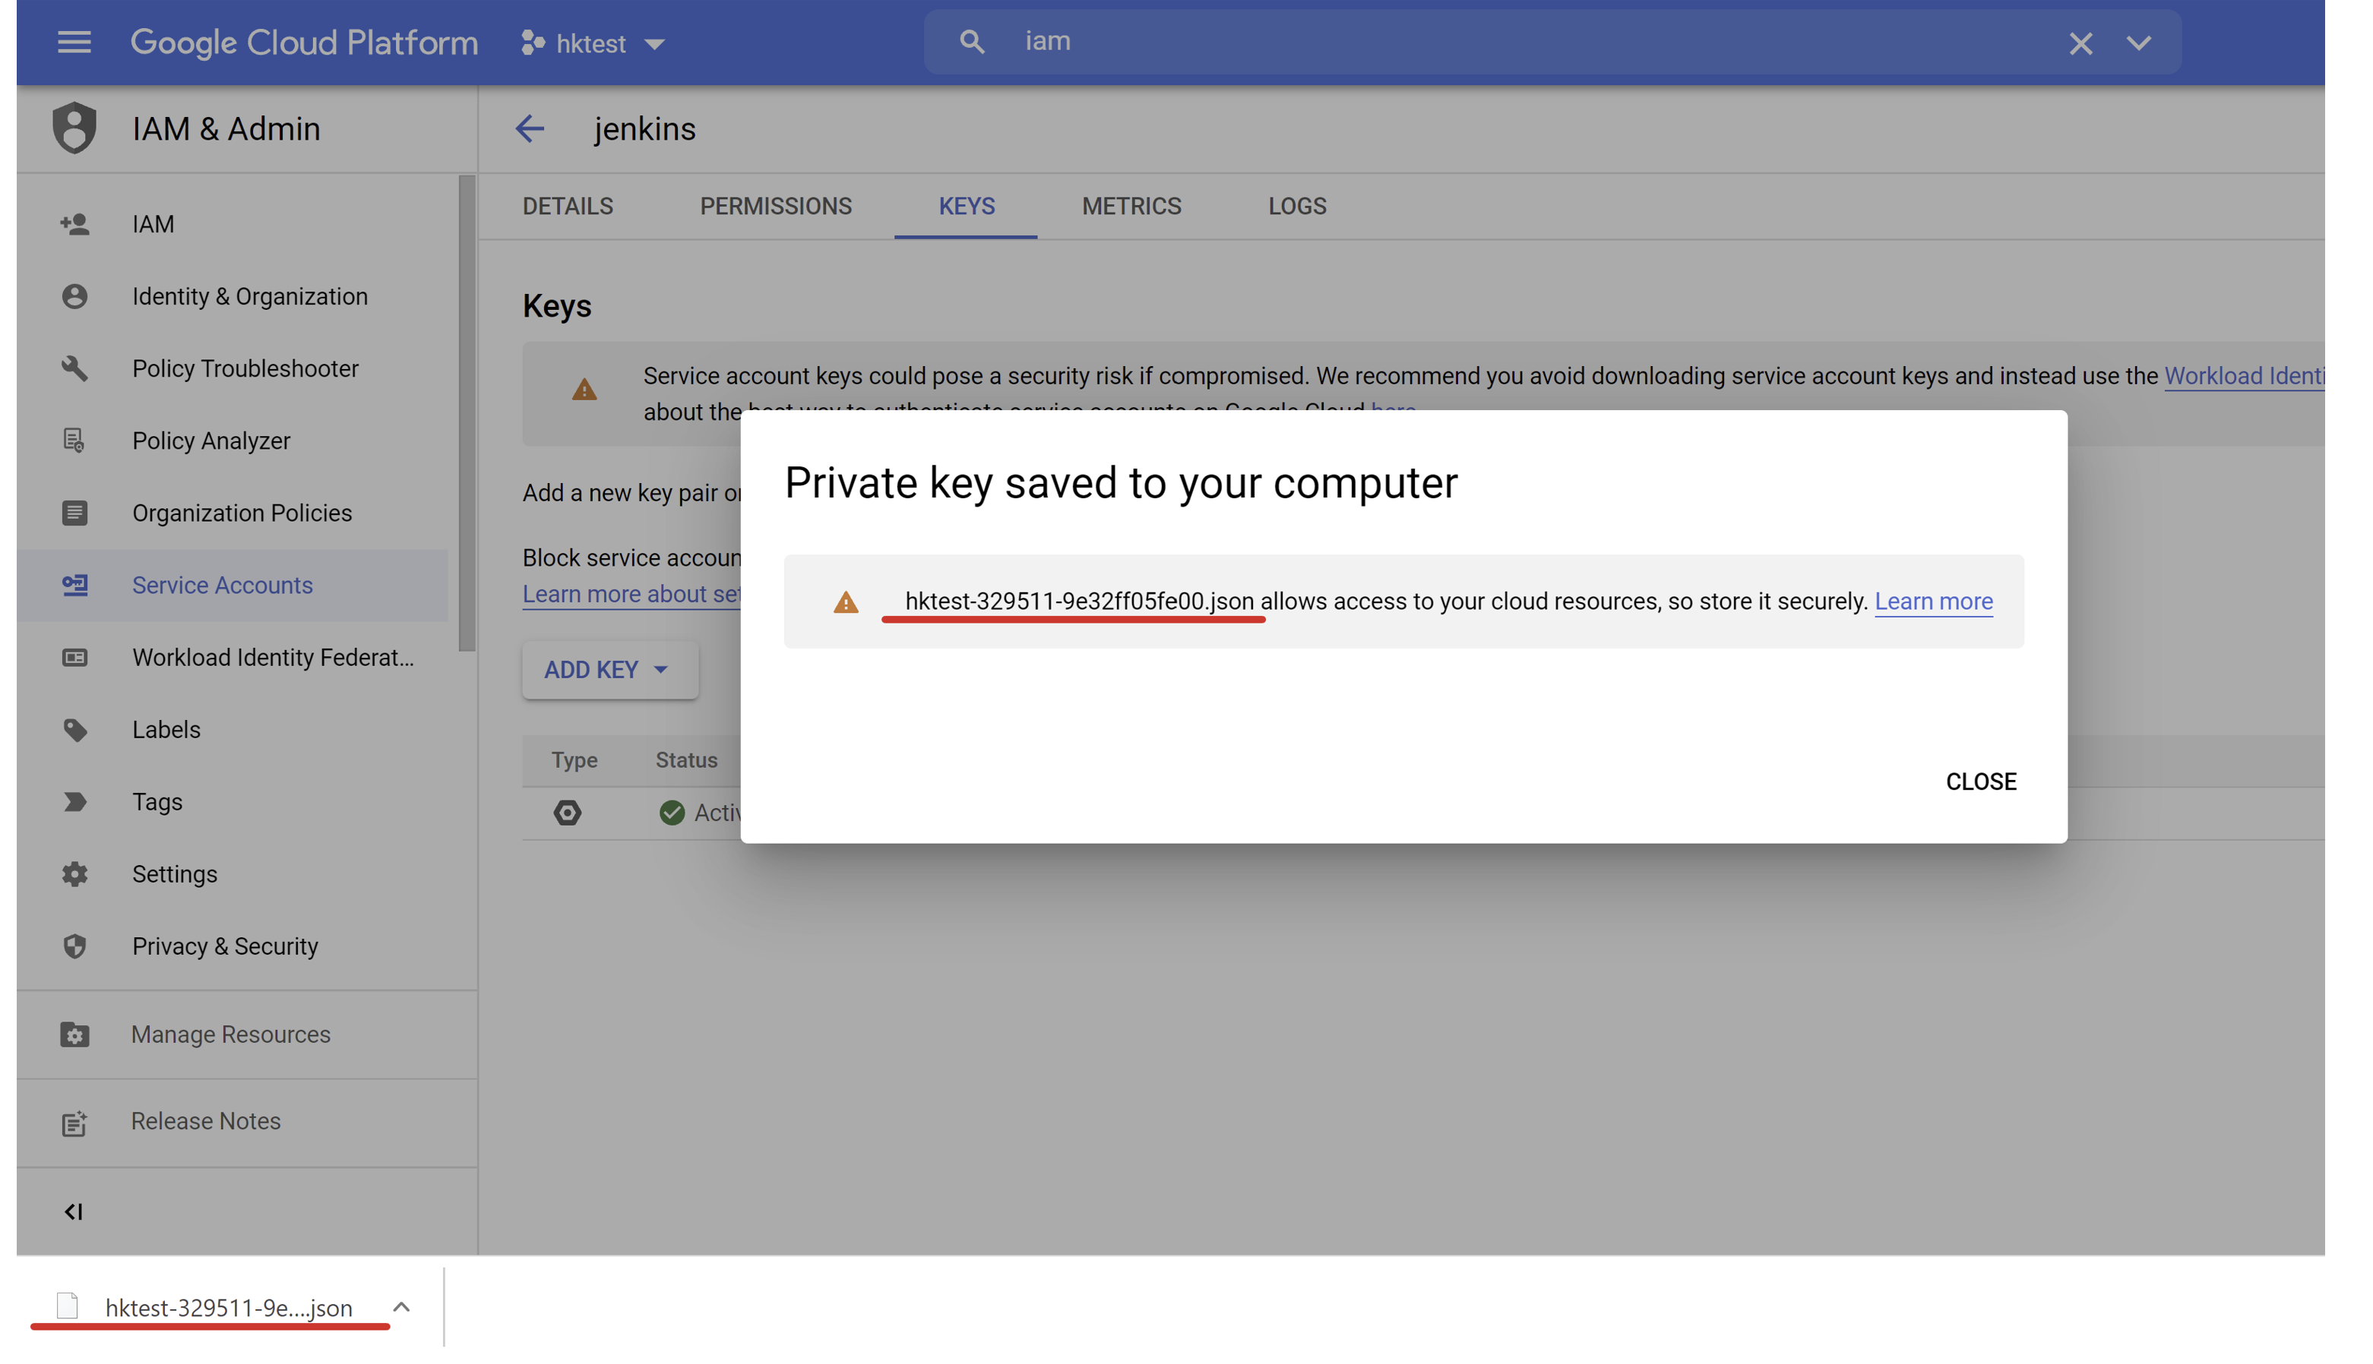

Now execute the gcloud auth activate-service-account command to authenticate your gcloud against the credentials. Option --key-file should point to the JSON credential file you just generated and downloaded. If you're running this command on a remote machine, you will need to make sure you have access to the credentials file on the remote machine when you run this command.

$ gcloud auth activate-service-account --key-file hktest-329511-99a9b49a5ffd.json

Activated service account credentials **for**: [jenkins@hktest-329511.iam.gserviceaccount.com]

If you execute the gcloud auth list command now you should see that apart from your named account, there is also jenkins@hktest-329511.iam.gserviceaccount.com service account registered in gcloud.

$ gcloud auth list

Credentialed Accounts

ACTIVE ACCOUNT

* john.doe@yourcompany.com

jenkins@hktest-329511.iam.gserviceaccount.com

**To** set the active account, run:

$ gcloud config set account `ACCOUNT`

As you can see even though you successfully registered your service account in gcloud, it may not be the account currently used by GCP SDK. In order to make it *active* execute the following command:

$ gcloud config set account jenkins@hktest-329511.iam.gserviceaccount.com

Updated property [core/account].

Congratulations! Now all your gcloud commands will be executed against your service account instead of your named account.

# GCP compute engine service

## Contents

* [Overview](https://qa-community.co.uk/~/_/learning/lbg-gcp/gcp--compute#overview)
  + [GCP Compute Engine](https://qa-community.co.uk/~/_/learning/lbg-gcp/gcp--compute#gcp-compute-engine)
  + [Multi-tenancy](https://qa-community.co.uk/~/_/learning/lbg-gcp/gcp--compute#multitenancy)
* [Tutorial](https://qa-community.co.uk/~/_/learning/lbg-gcp/gcp--compute#tutorial)
* [Exercises](https://qa-community.co.uk/~/_/learning/lbg-gcp/gcp--compute#exercises)

## Overview

There are three pillars of cloud services.

* Storage
* Network
* Compute

While storage services are used to persist your data and network services are used to transfer this data over one computer to another, compute services are "cloud computers" themselves. You can think of compute services are a way to provision a virtual machine on a cloud infrastructure.

### GCP Compute Engine

Compute Engine is a service from GCP dedicated for running compute instances on Google Cloud Platform. It is an equivalent of AWS EC2 service from Amazon or Azure Virtual Machines service from Microsoft.

Compute Engine is a compute foundation for all the other GCP services.

### Multi-tenancy

Keep in mind that a single virtual cloud machine rarely corresponds to a single physical server. Instead, the cluster of physical machines in a data center is used to host multiple virtual compute instances. It is very likely then that when you create a new virtual machine, it is co-located on a physical machine with the virtual machines of other GCP customers. It is Google's (and virtualization software's) responsibility to ensure that these two virtual instances are co-existing in a secure manner and that two tenants cannot access each other data.

Such approach for sharing resources between multiple customers is called multi-tenancy.

## Tutorial

In this tutorial you will learn how to create a new Ubuntu Linux compute instance in GCP and how to access it via SSH protocol.

Let's start by navigating your browser to the GCP Console. In the services menu on the left side of the screen find "Compute" section. Then click "Compute Engine" item in a menu.

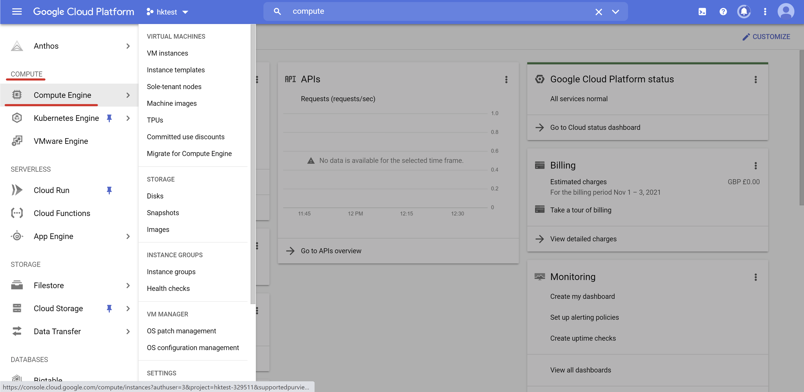

You should see Compute Engine screen right now. Click "Create Instance" button at the top of that screen.

[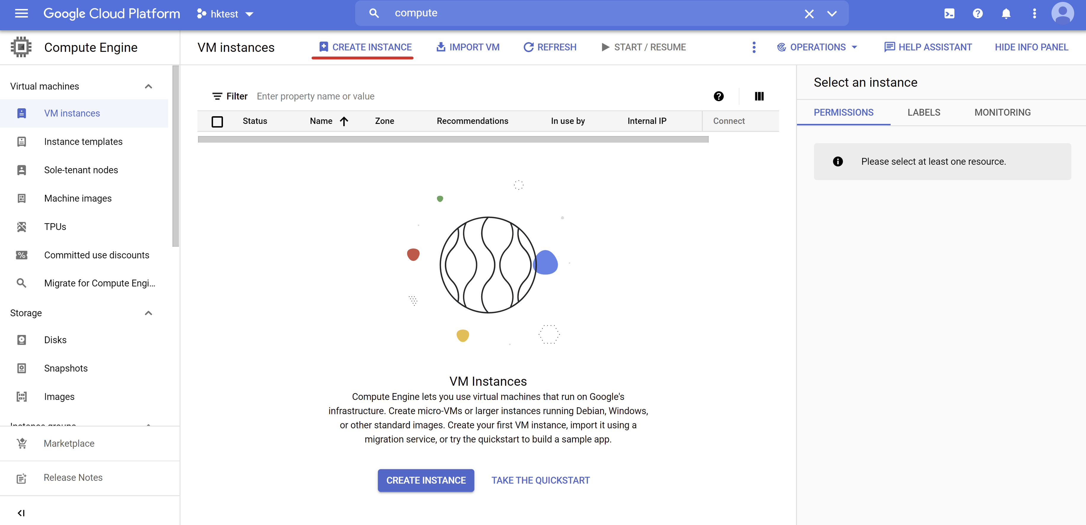](https://gyazo.com/fa02bfe1b667bf61894558e438051428)

You should see an instance configuration screen now. You have to specify the name of the instance you want to create.

[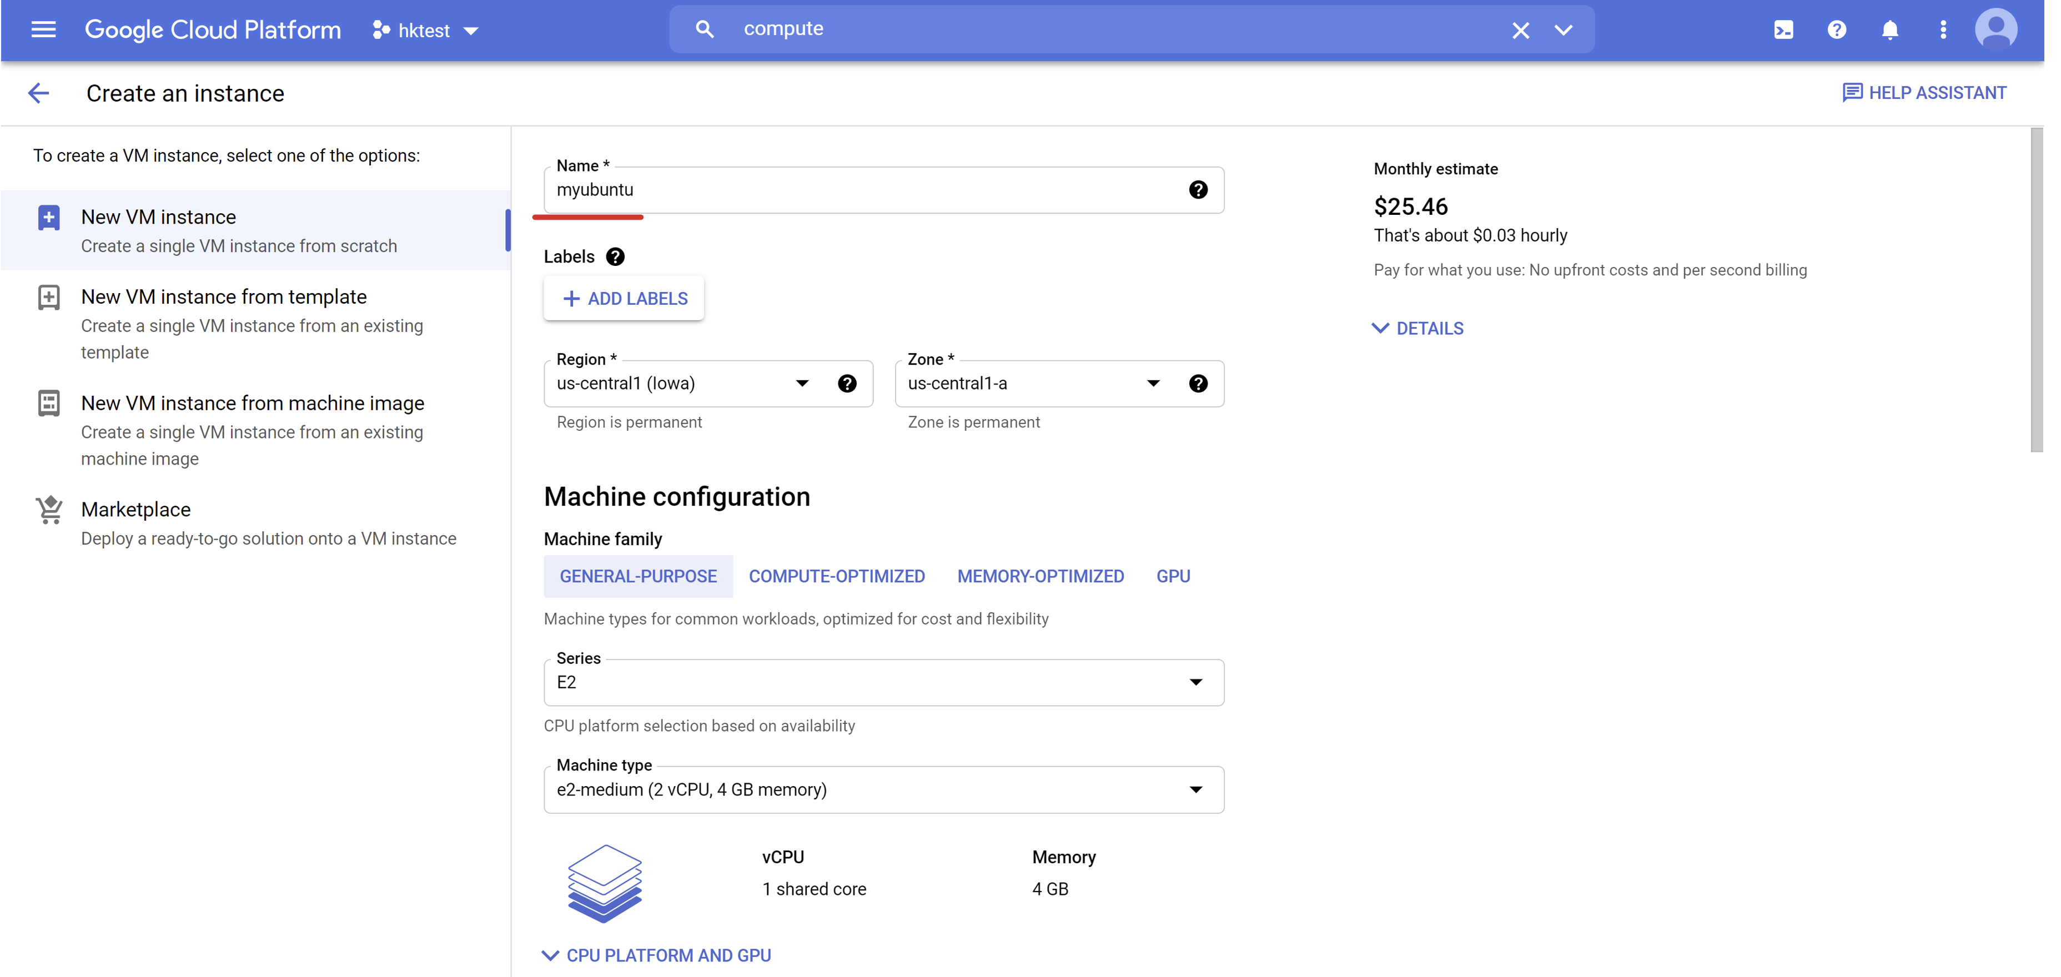](https://gyazo.com/3f69a42e137bb73a88a575734ff8c518)

Let's keep all the settings with default values. The only thing we would like to change is the instance image. Navigate to the "Boot disk" section then and replace default Debian image with Ubuntu by clicking "Change" button.

[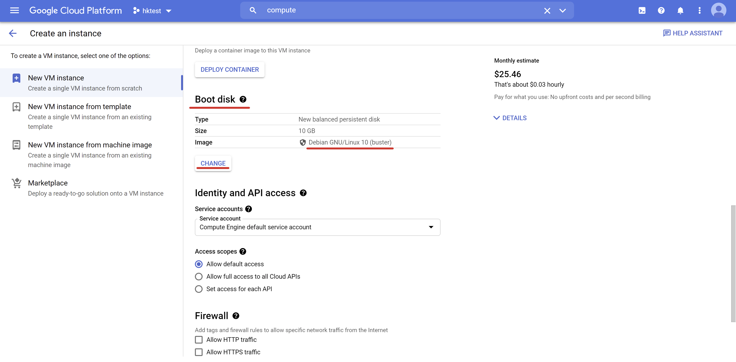](https://gyazo.com/e4a88b671815c783a54c06346317bcbf)

From the "Public Images" tab select the "Operating system" filter input. Type ubuntu into that filter input and select Ubuntu.

[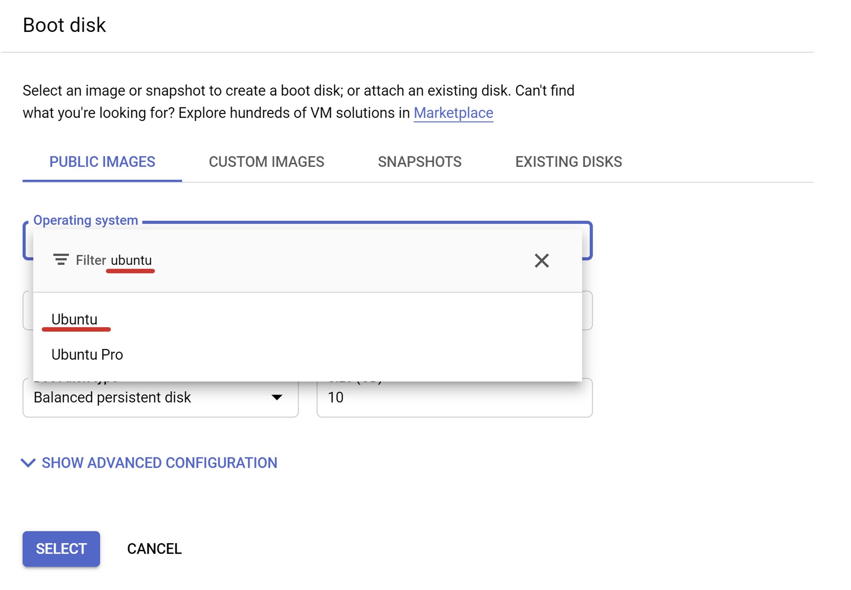](https://gyazo.com/c6c631cc0449acd2646d59a0c17a86de)

From the available Ubuntu versions choose **20.04 LTS** and click **Select** button.

[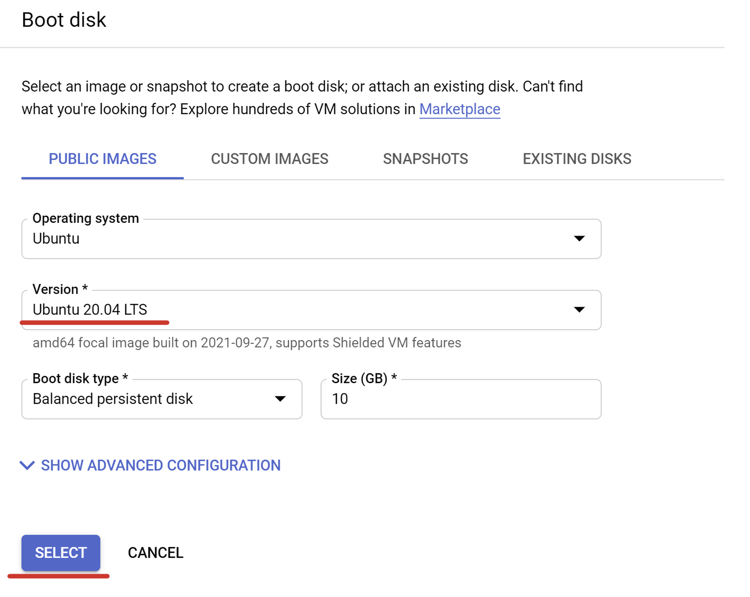](https://gyazo.com/deca0d230727d63c93a9ddb5a2455f58)

Now you are ready to start your new virtual machine. Click the "Create" button then!

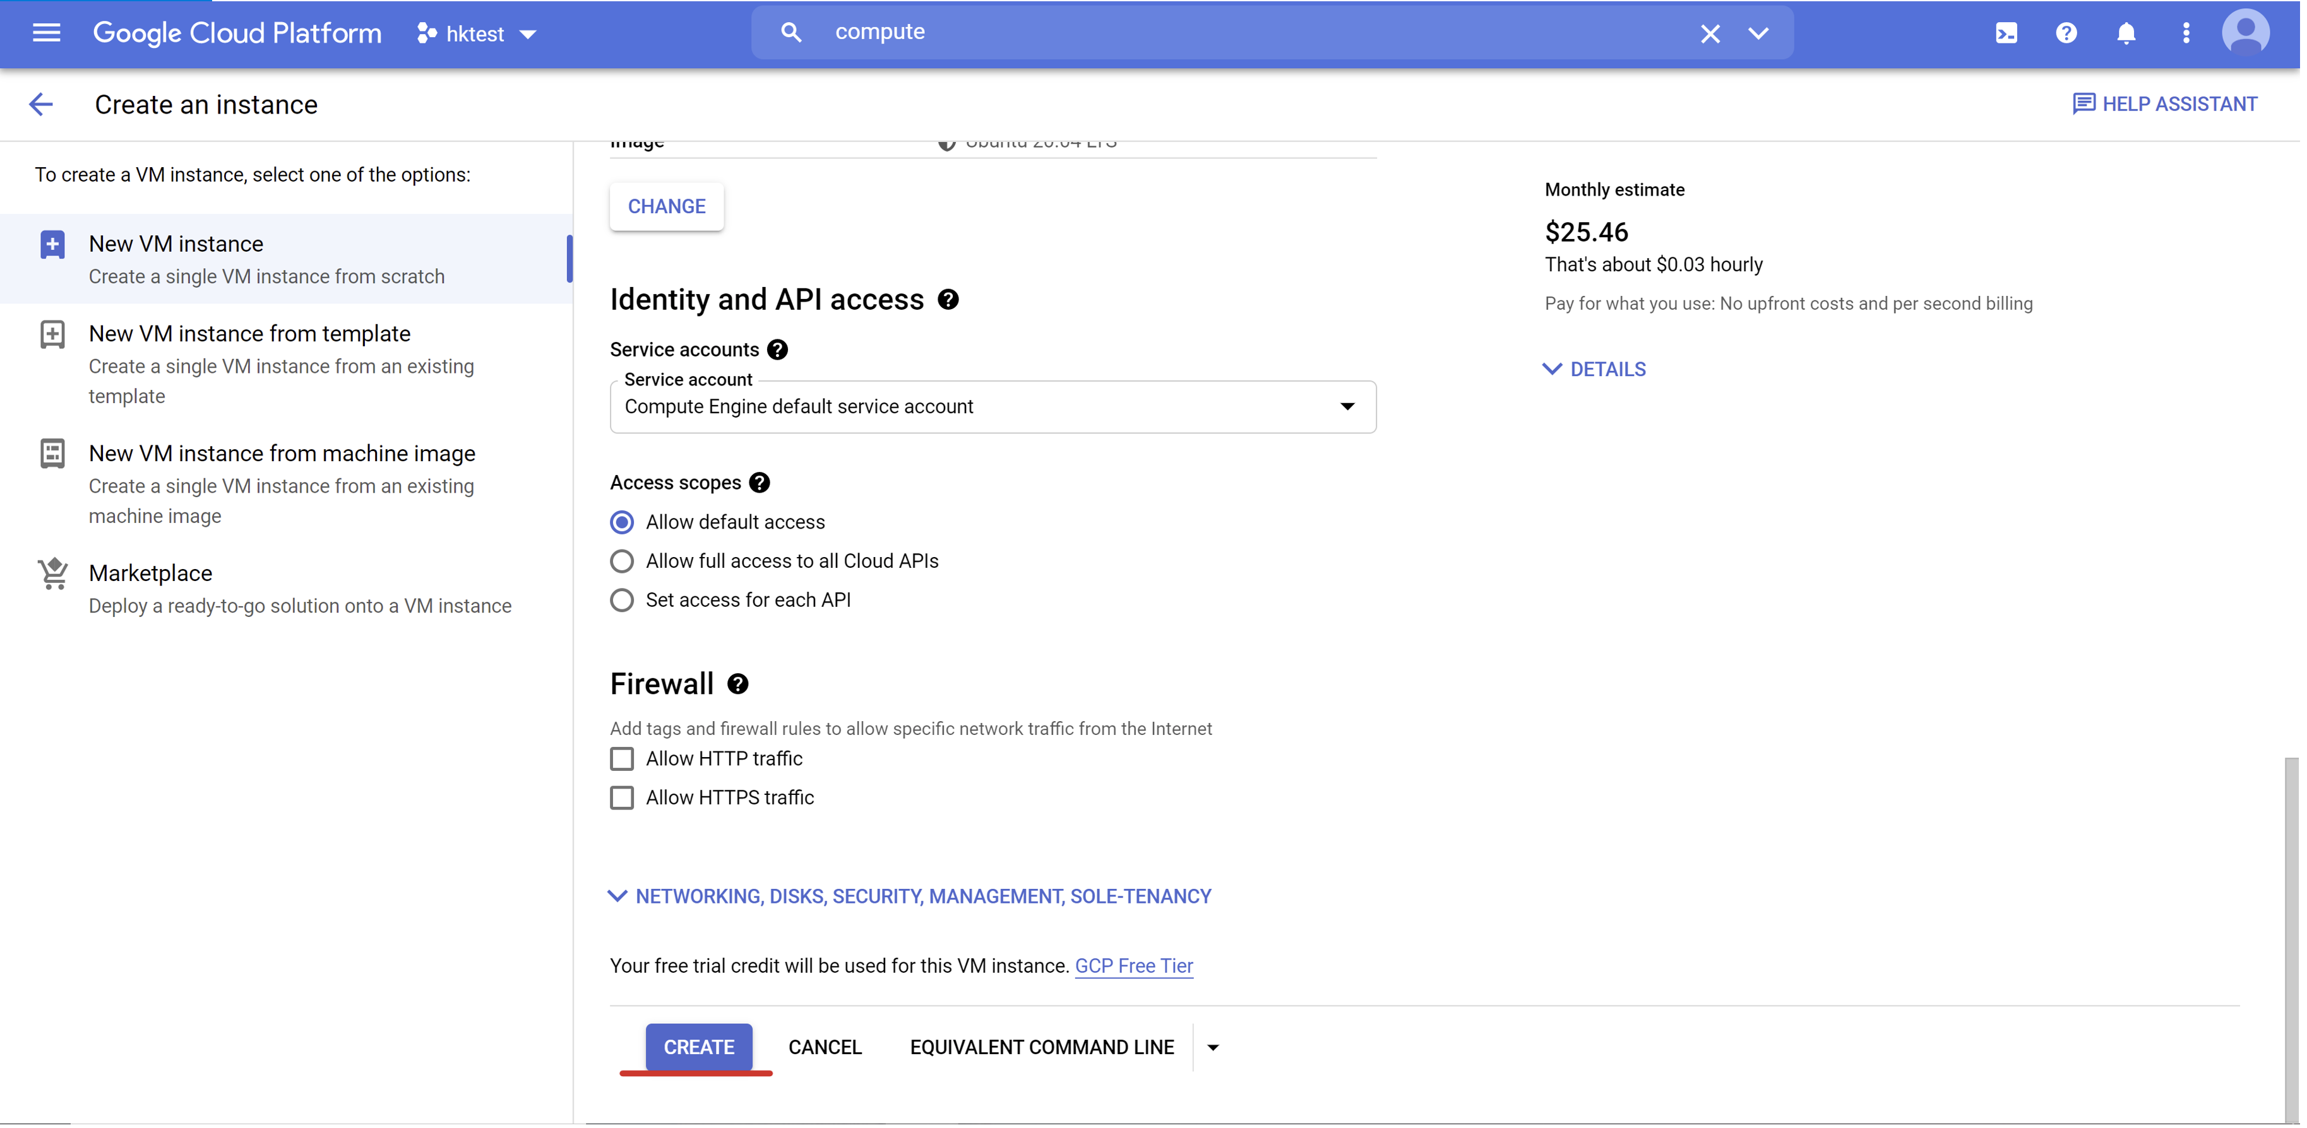

You will be redirected back to the Compute Engine main page. You should see your instance on the list with spinning icon on the left side of its name. That spinner indicates that instance is being currently provisioned.

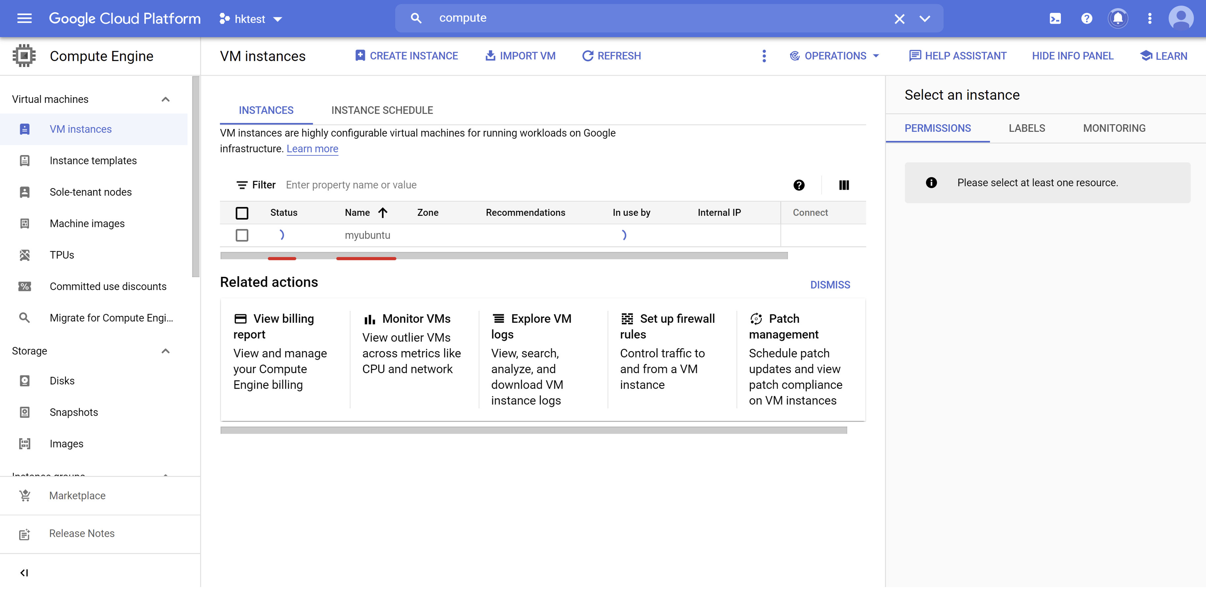

After spinner icon turns into a green one, click the name of your virtual machine. It means that the instance has been provisioned for you and we are ready to connect to it!

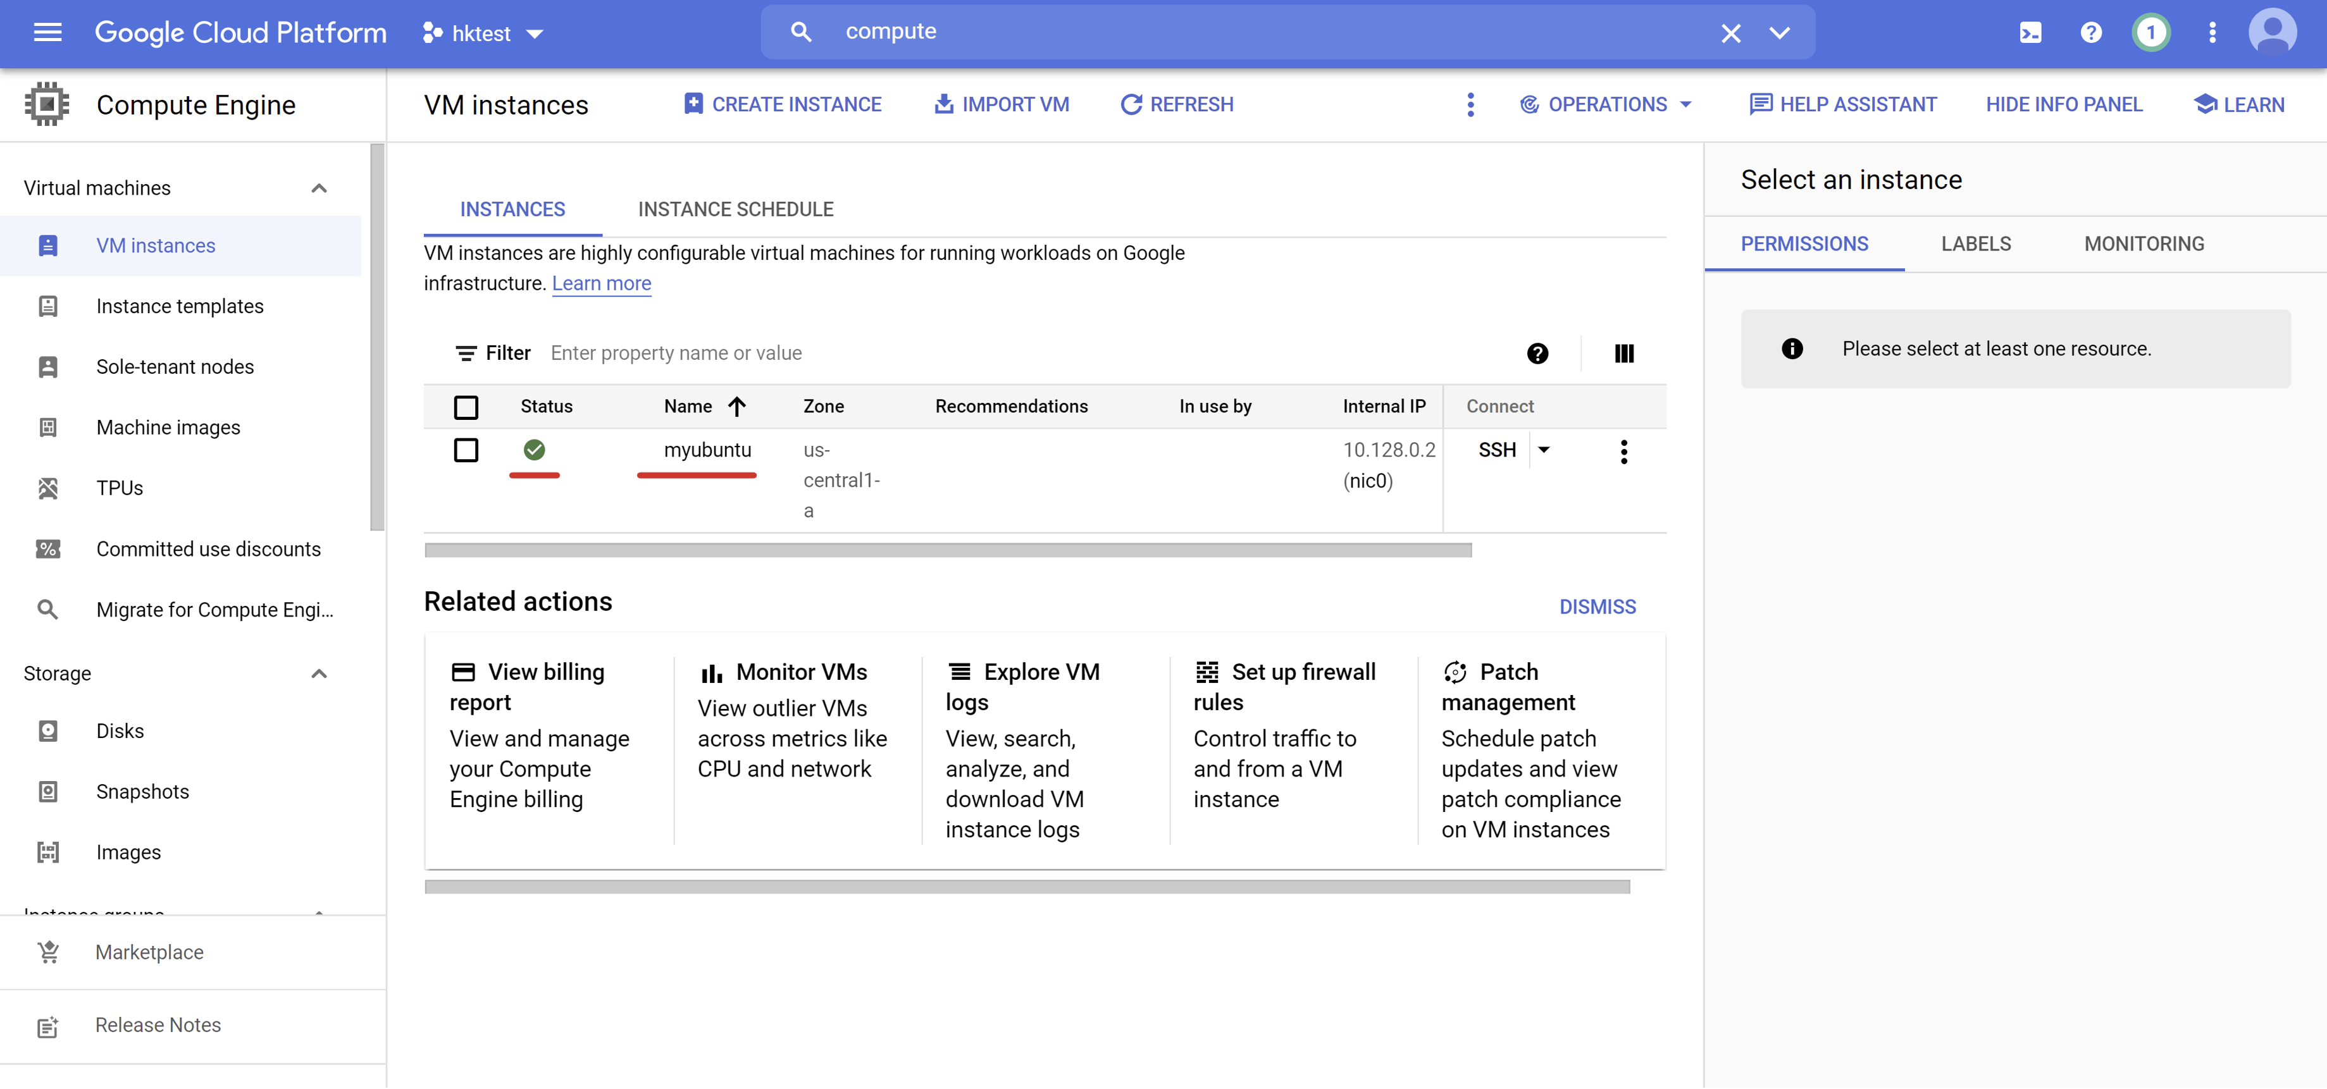

Click "Open in browser window" option in the "SSH" tab.

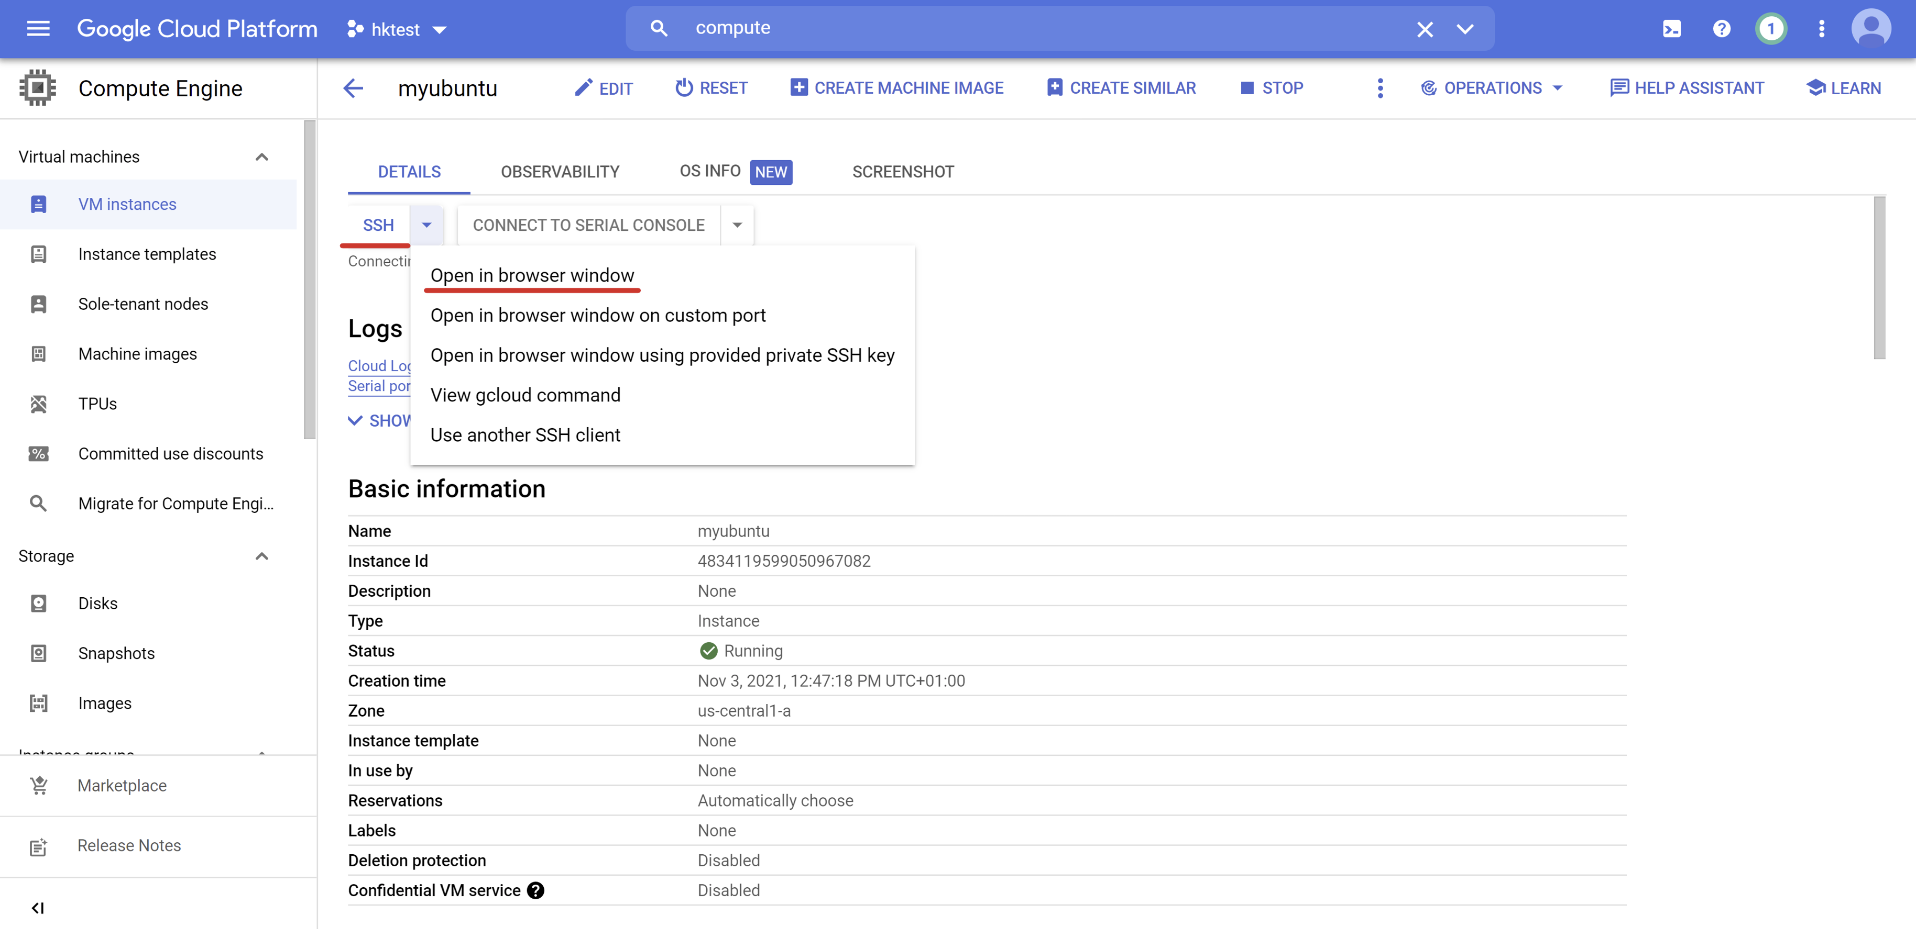

You should see new SSH connection window now. GCP needs some time to transfer SSH public keys into your instance. It may take a moment.

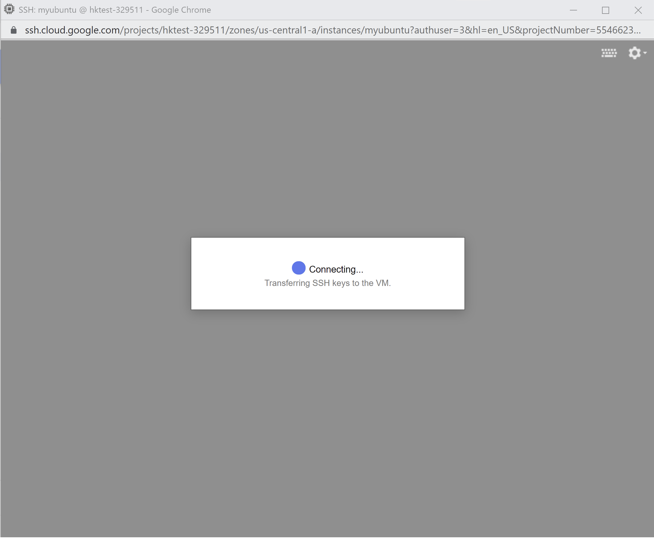

As soon as keys are transferred to the target machine, GCP will establish an SSH connection between your browser window and a given virtual machine. You should see your Ubuntu terminal ready to be used.

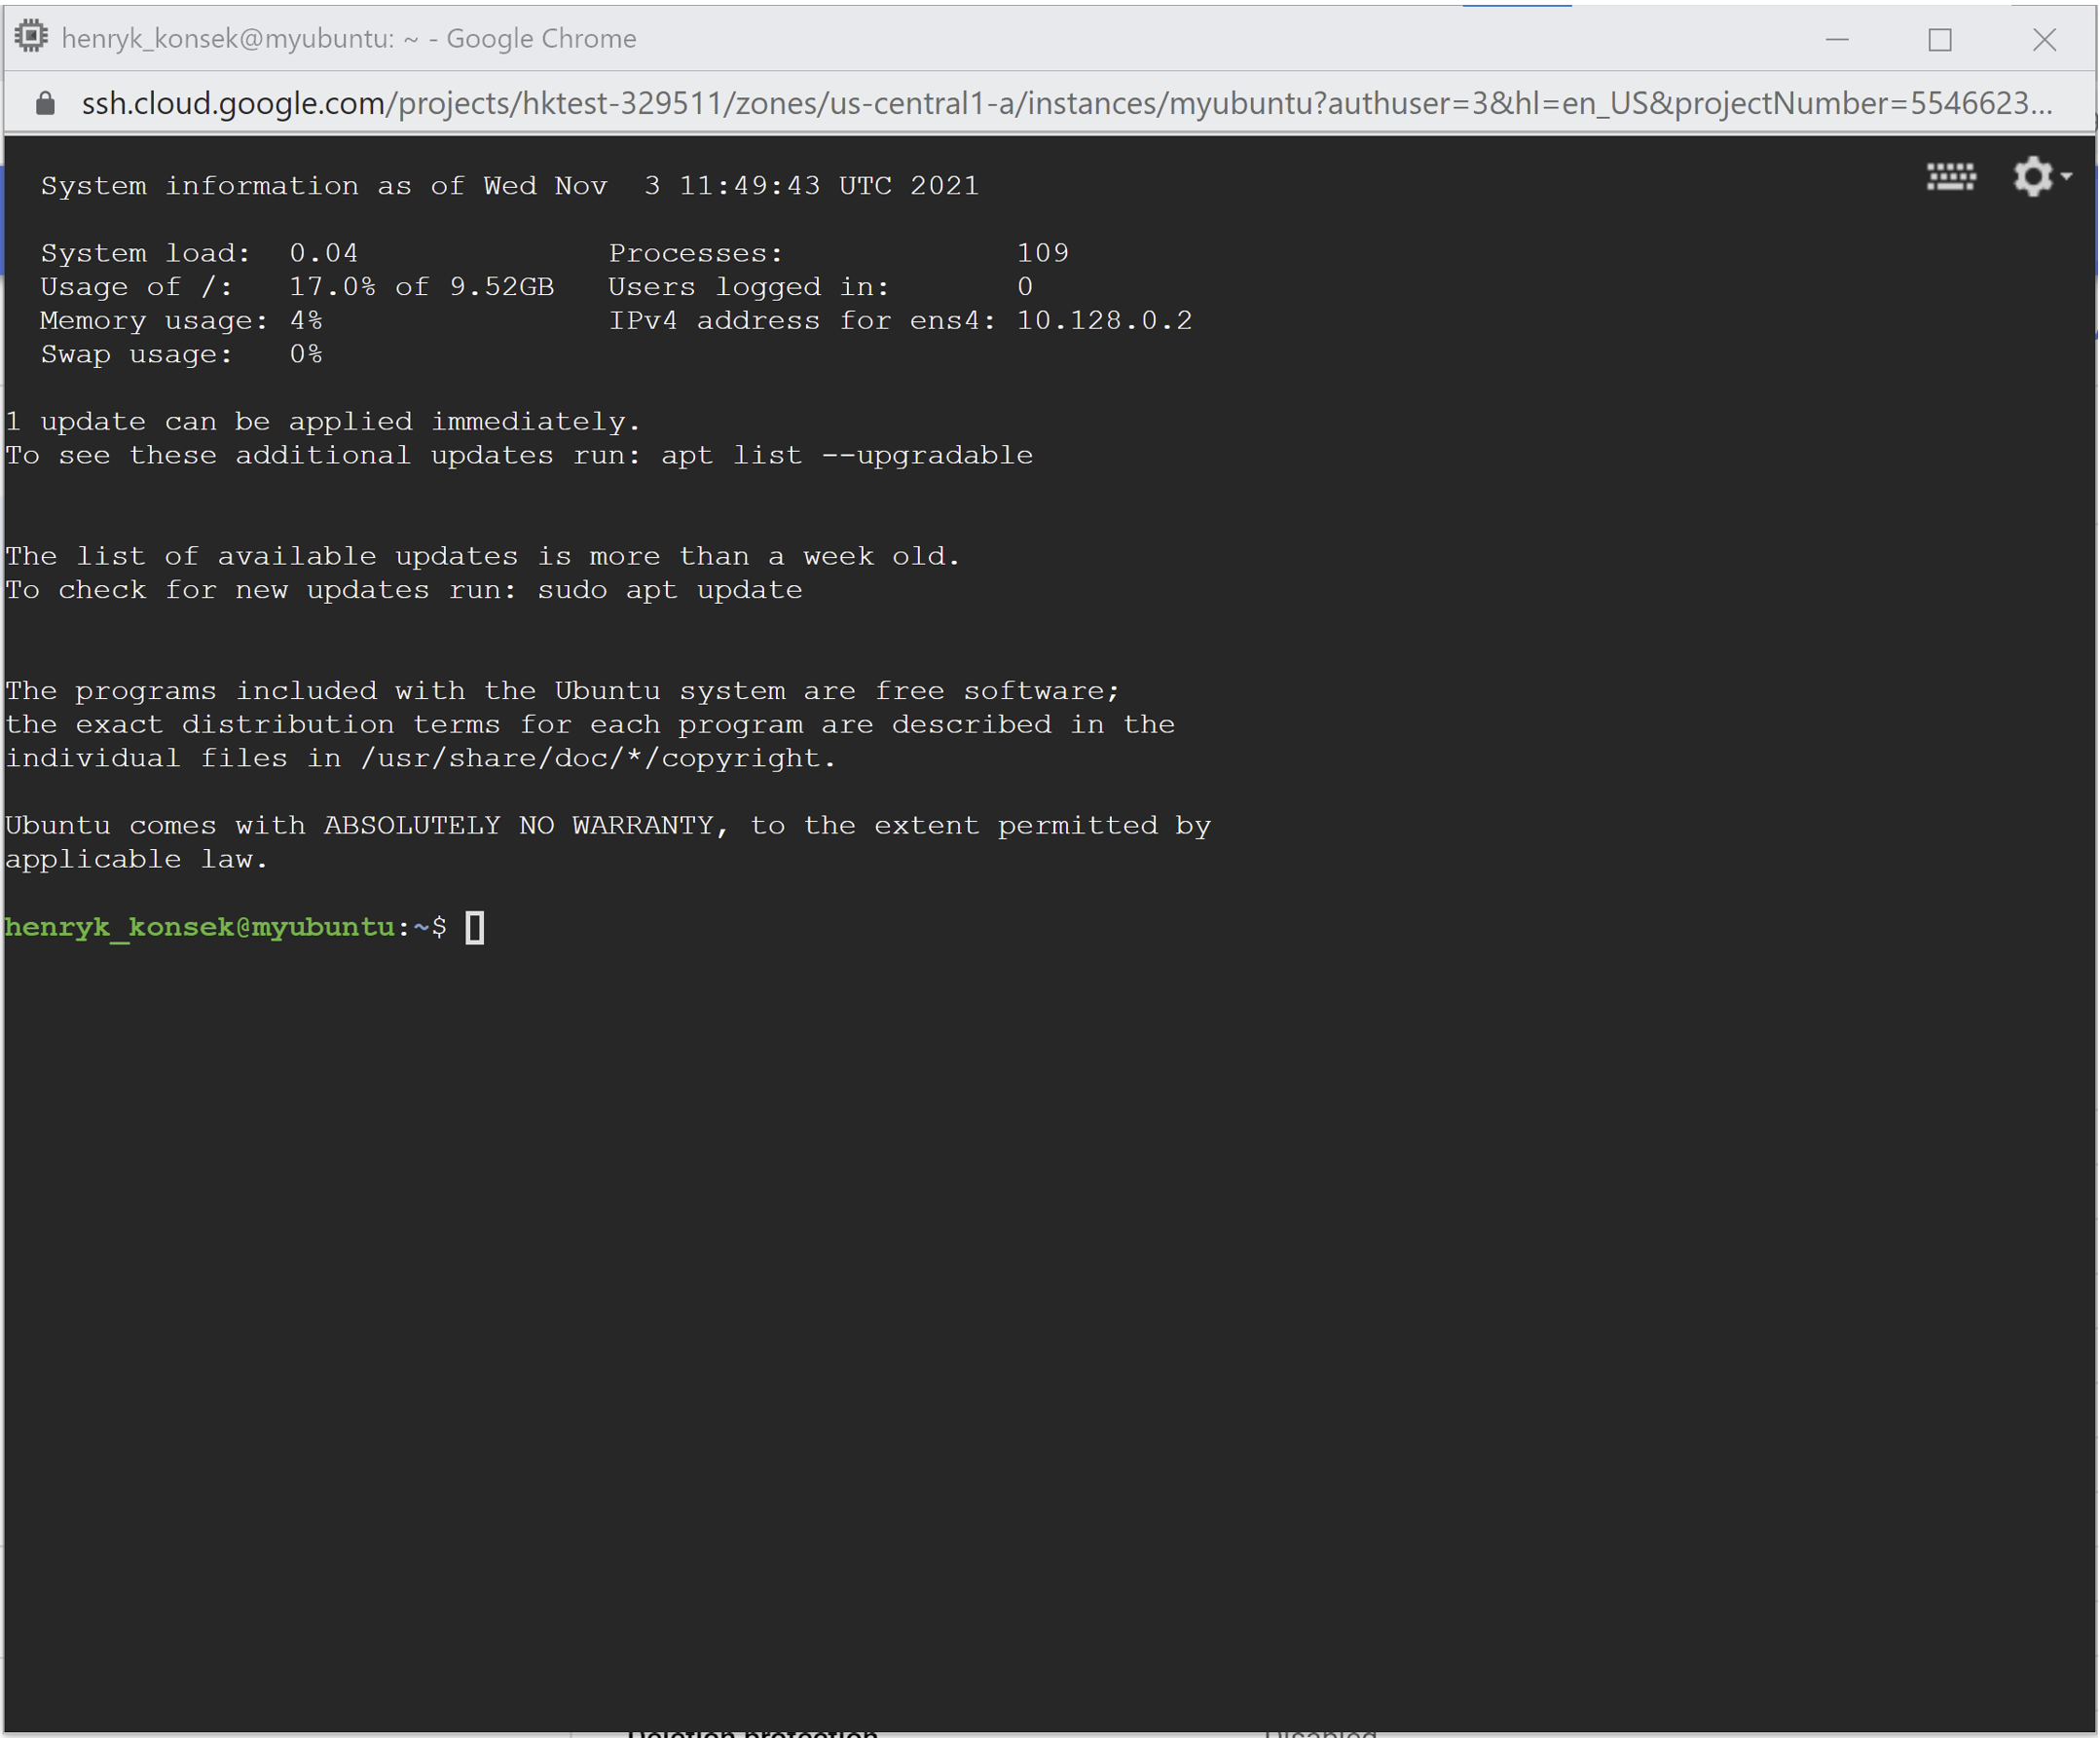

You can start executing Linux commands on your new instance. For example executing uptime command can confirm that our instance has been started just a couple of minutes ago.

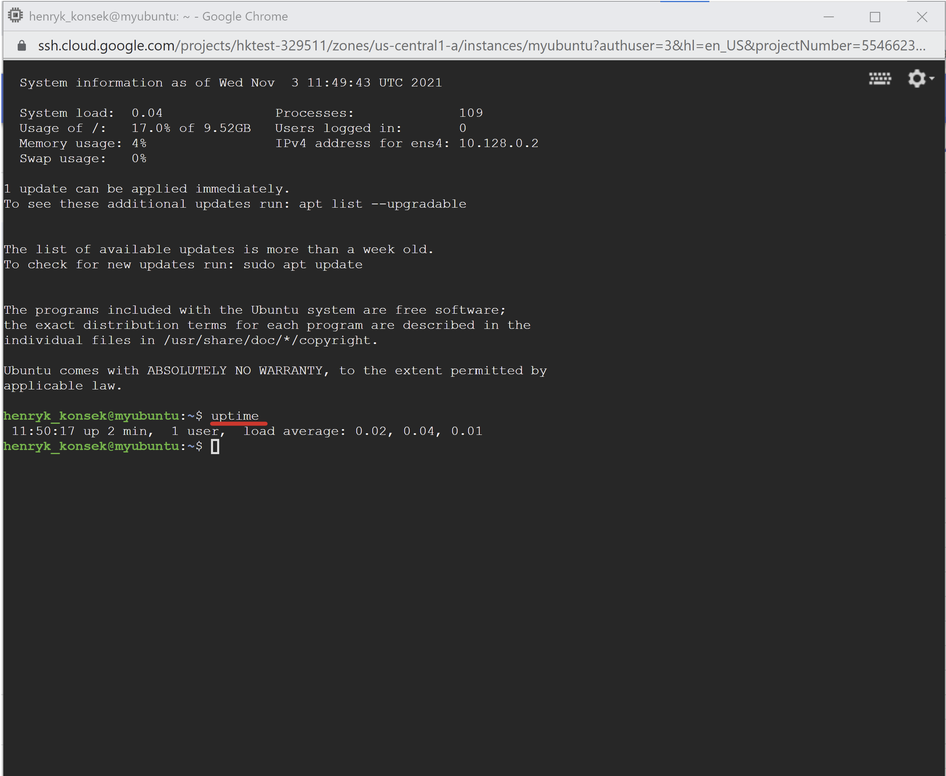

# Google Cloud Platform IAM service accounts

## Contents

* [Overview](https://qa-community.co.uk/~/_/learning/lbg-gcp/gcp--iam-service-account#overview)
* [Tutorial](https://qa-community.co.uk/~/_/learning/lbg-gcp/gcp--iam-service-account#tutorial)
* [Exercises](https://qa-community.co.uk/~/_/learning/lbg-gcp/gcp--iam-service-account#exercises)

## Overview

Usually when you perform an operation against any GCP service API you will be using your IAM user associated with your named SSO account. For example your SSO Google Workspaces user e-mail could be john.doe@yourdomain.com and your IAM user name could be john.doe.

There are cases however when some user is not human, but a machine. For example Jenkins server pushing Docker images into GCP Container Registry should not be associated with any human and should perform on its i.e. Jenkins' behalf. This is when **service accounts** come into play. Service account is an artificial IAM user, not associated with real human person registered in Google SSO.

For example to access GCP from Jenkins you should create a jenkins service account in your project IAM service and grant a minimal set of permissions to this service account, so it can perform only the operations required by it. For example our Jenkins service account could have only GCP Container Registry push role assigned to it, because all we want from it is to push Docker images into GCP Container Registry.

## Tutorial

In this tutorial we will create a Jenkins service account that is capable of pushing images into GCR Container Registry service.

Let's start by opening IAM service in GCP Console.

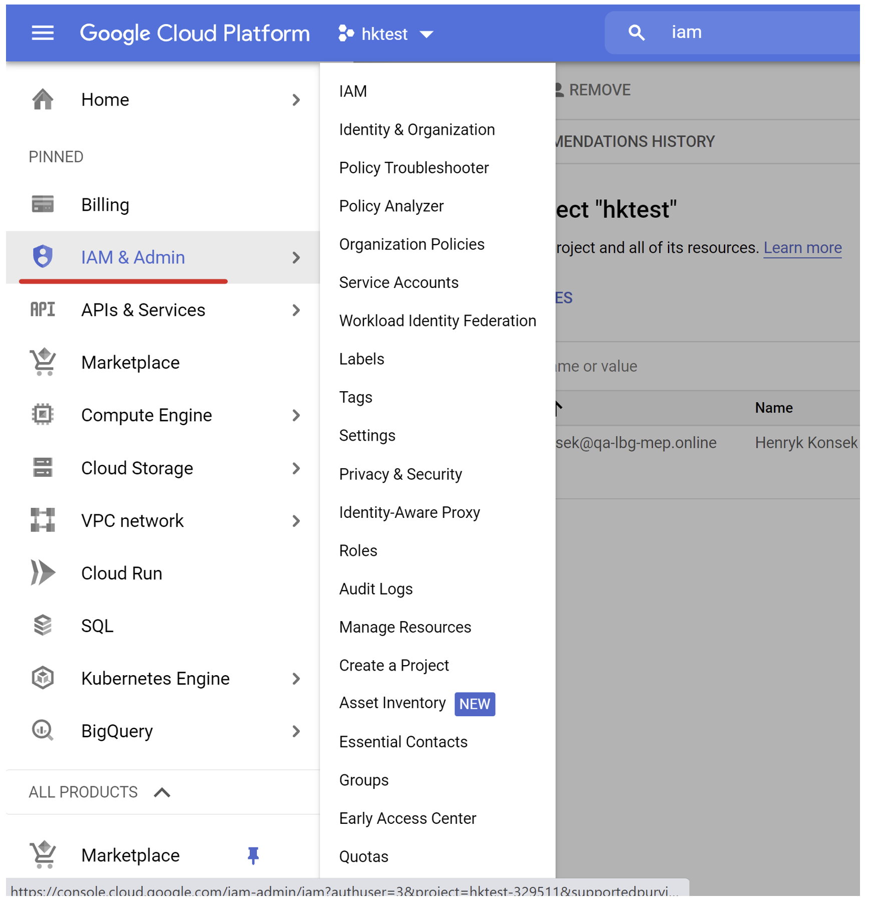

In the IAM menu on the left side of the screen choose the **Service Accounts** option.

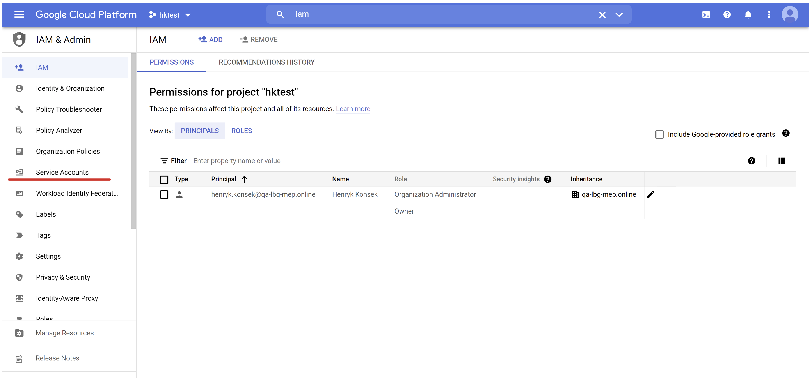

You should see the listing of all service accounts associated with the given project. Create new service account by clicking **Create Service Account** button at the top of the screen.

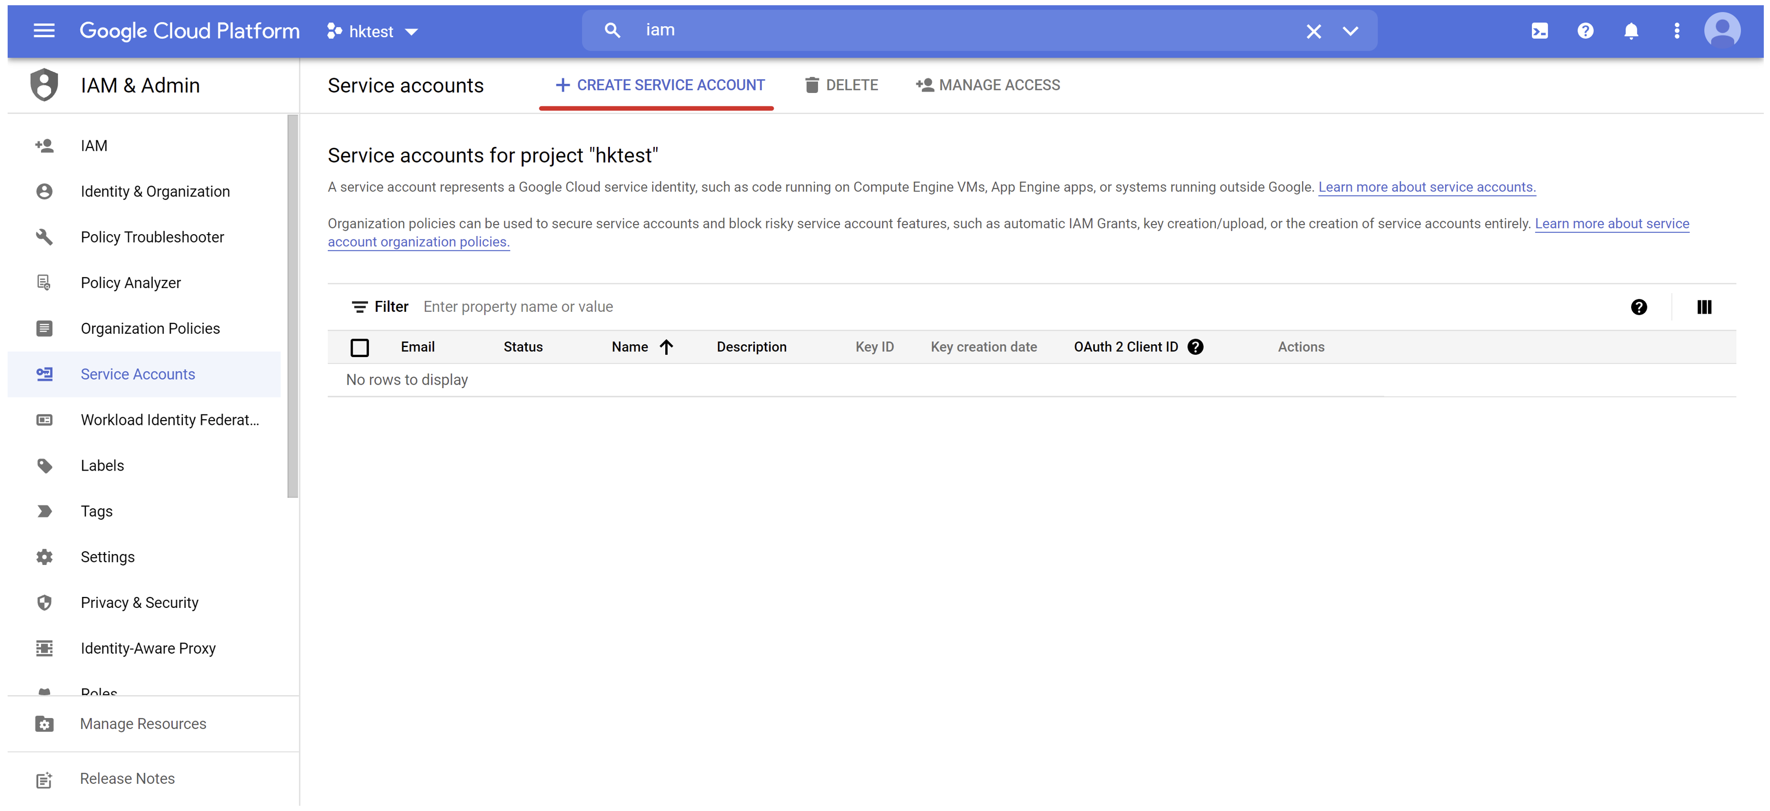

Select a short name for your service account, for example jenkins. GCP will create a full service account name by combining your short name with the GCP project name.

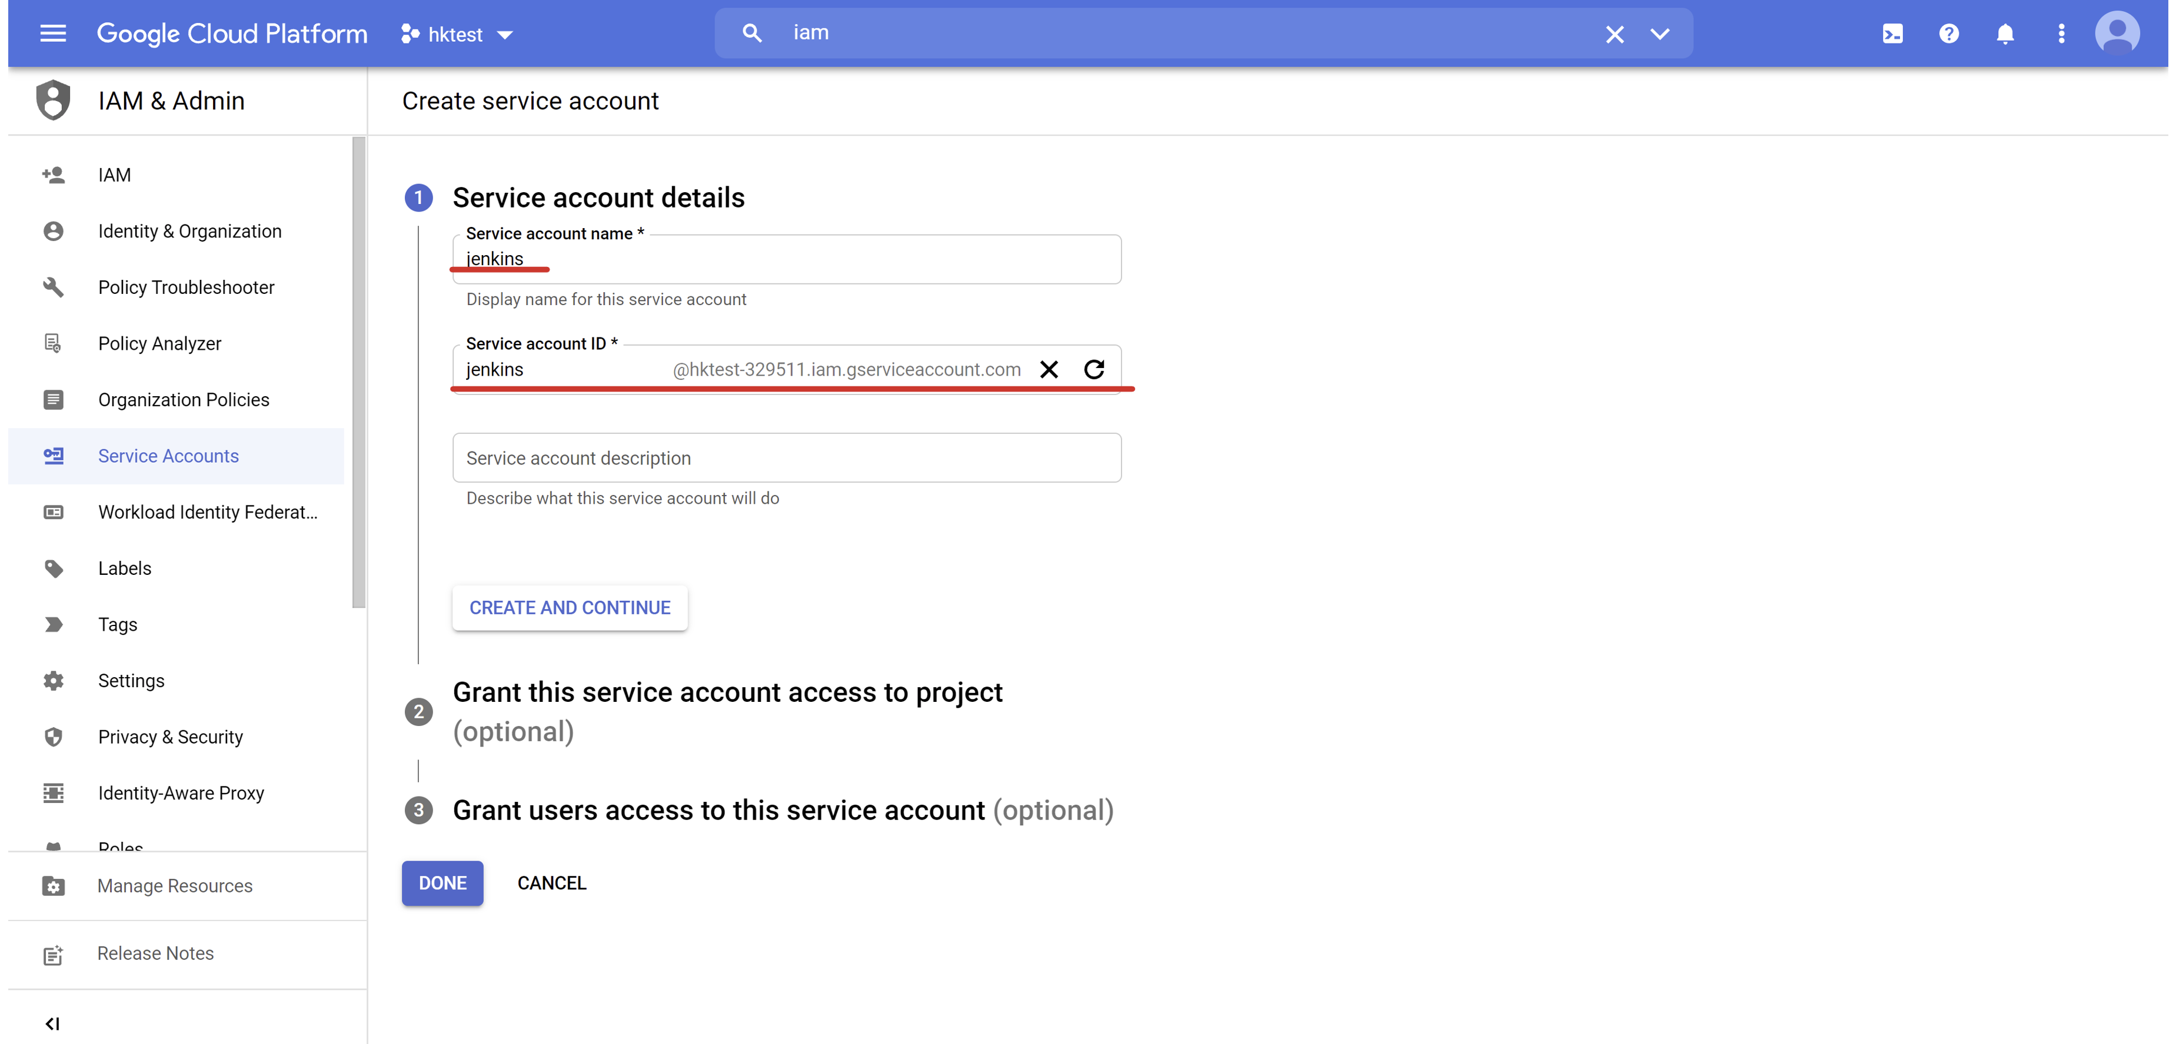

Click **Create And Continue** button.



Now GCP should take your to the permission configuration window. This is where you can specify what roles and permissions should be assigned to your service account.

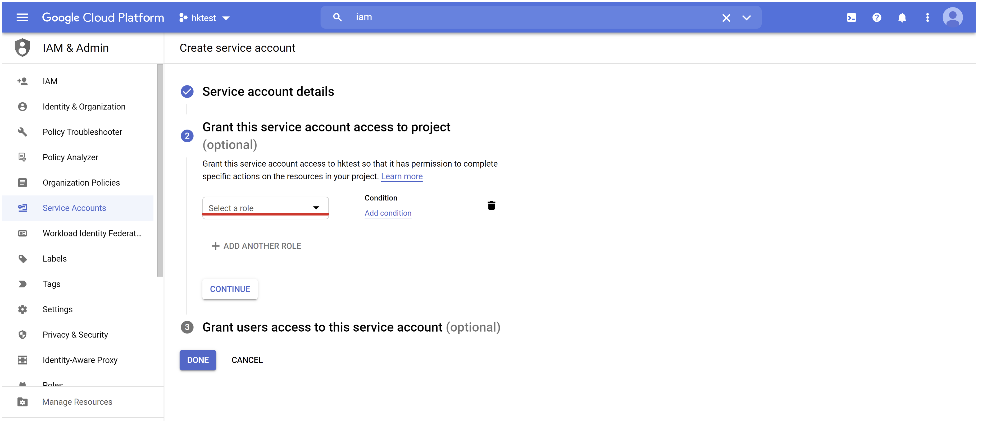

Click the role search input and type **storage admin**. You should see **Storage Admin** role available in the menu. This is the role required by Jenkins service account to push container images into GCP Container Service.

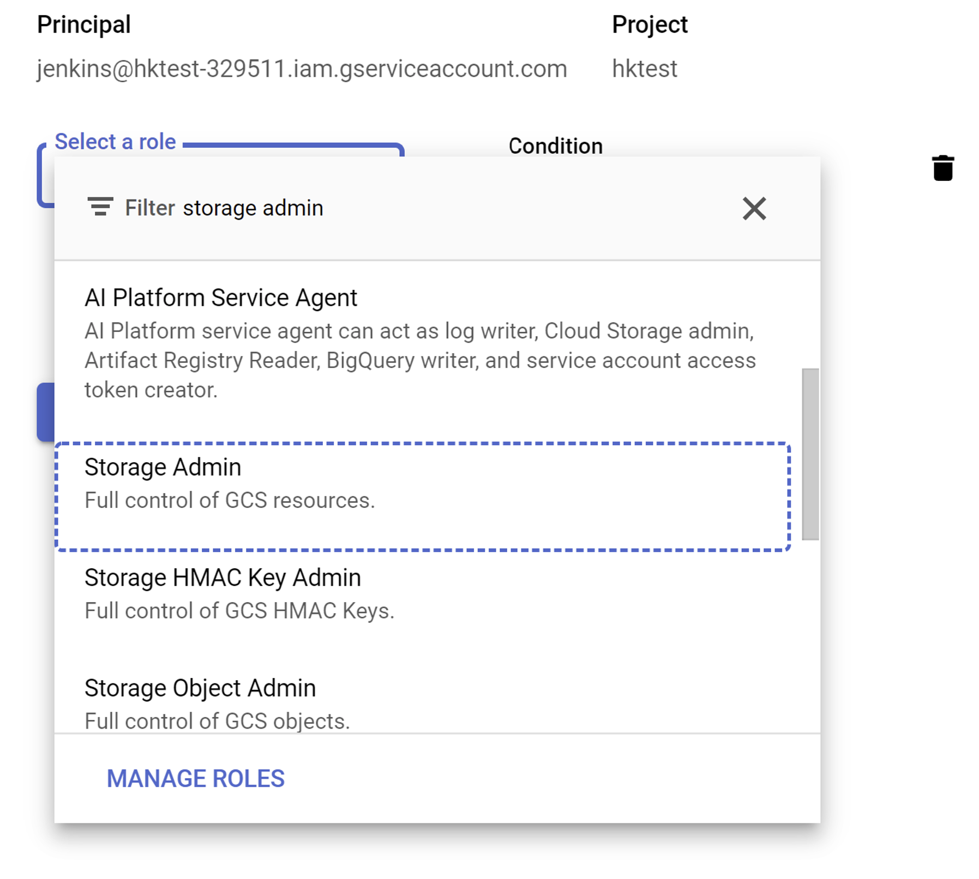

Select **Storage Admin** role then and click blue **Done** button.

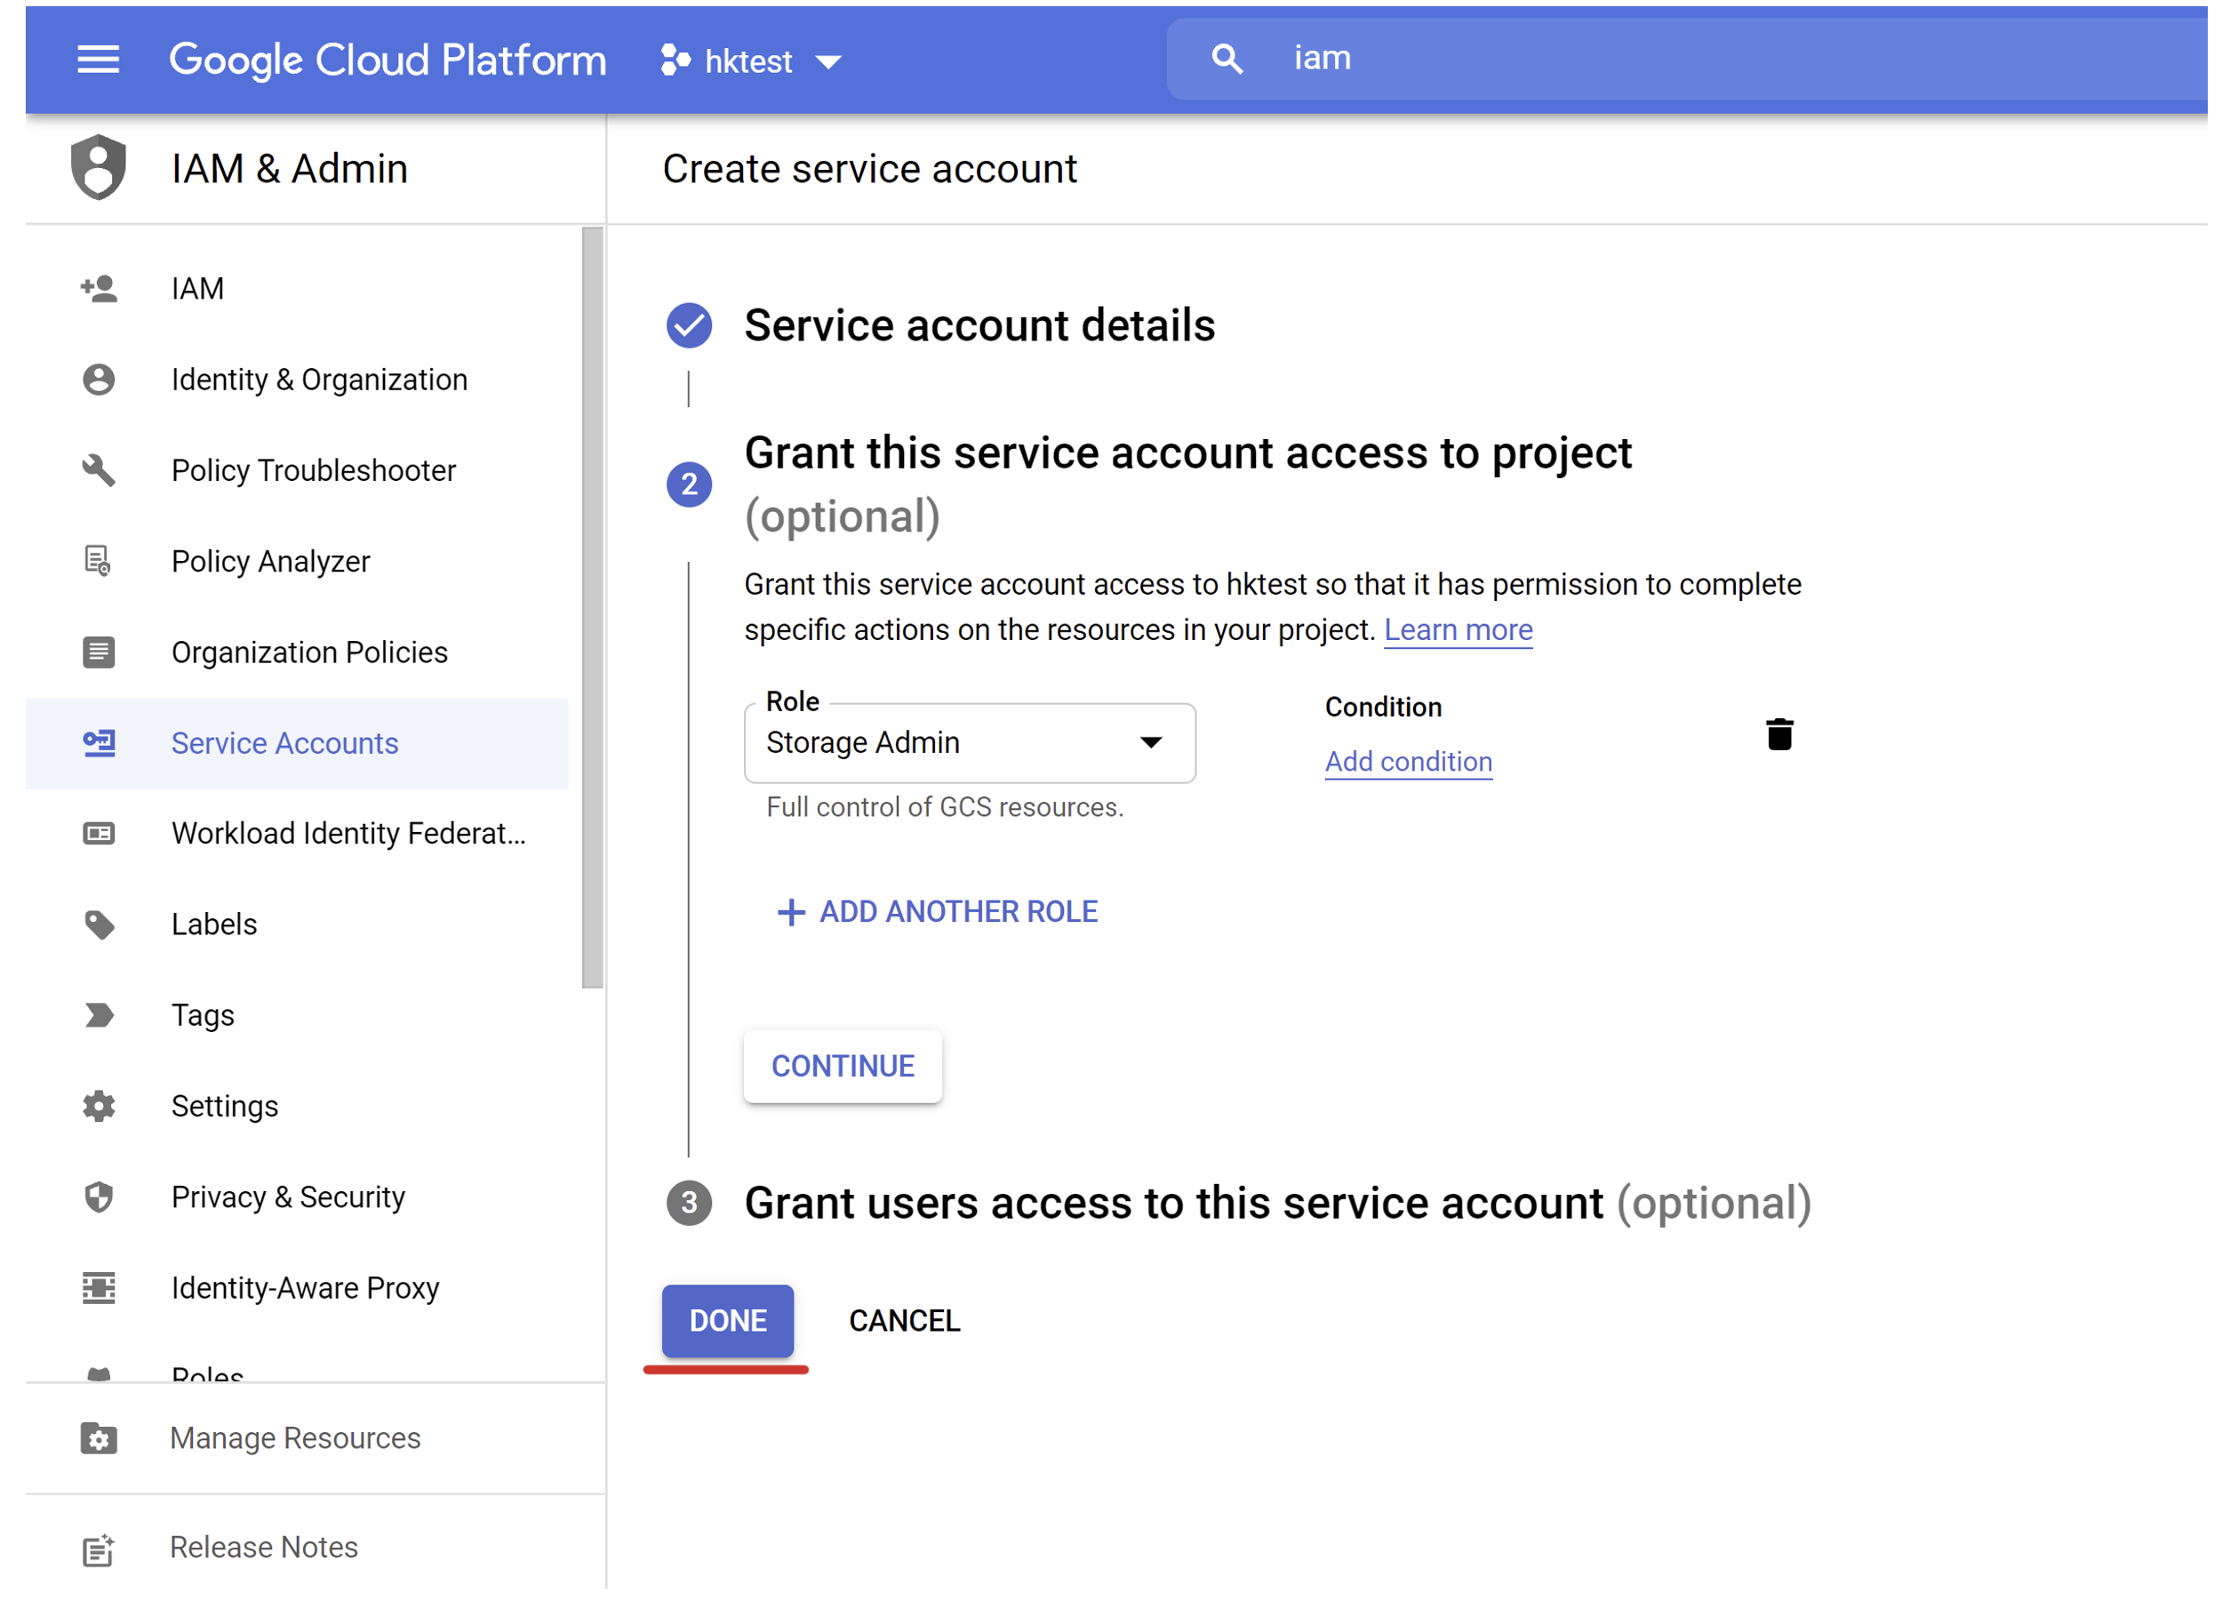

You should see your new Jenkins service account created in the service accounts list. Click the service account name to open account details window.

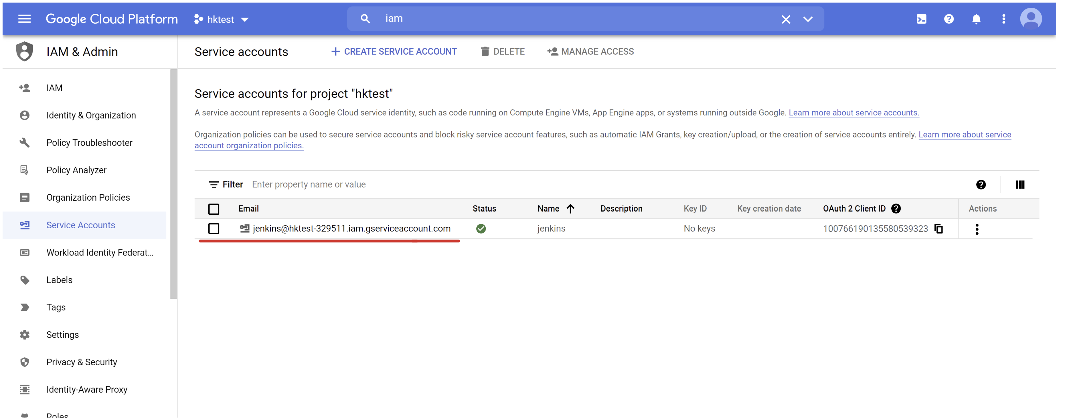

Select **Keys** tab and click **Add Key** button.

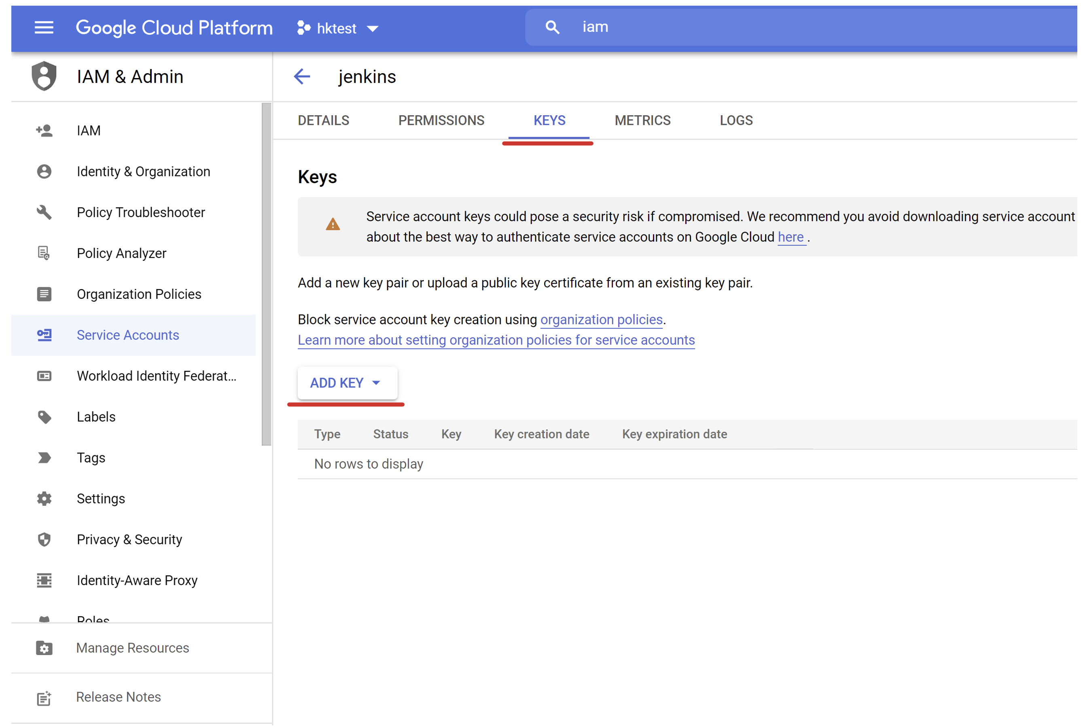

From the key menu select **Create new key** option.

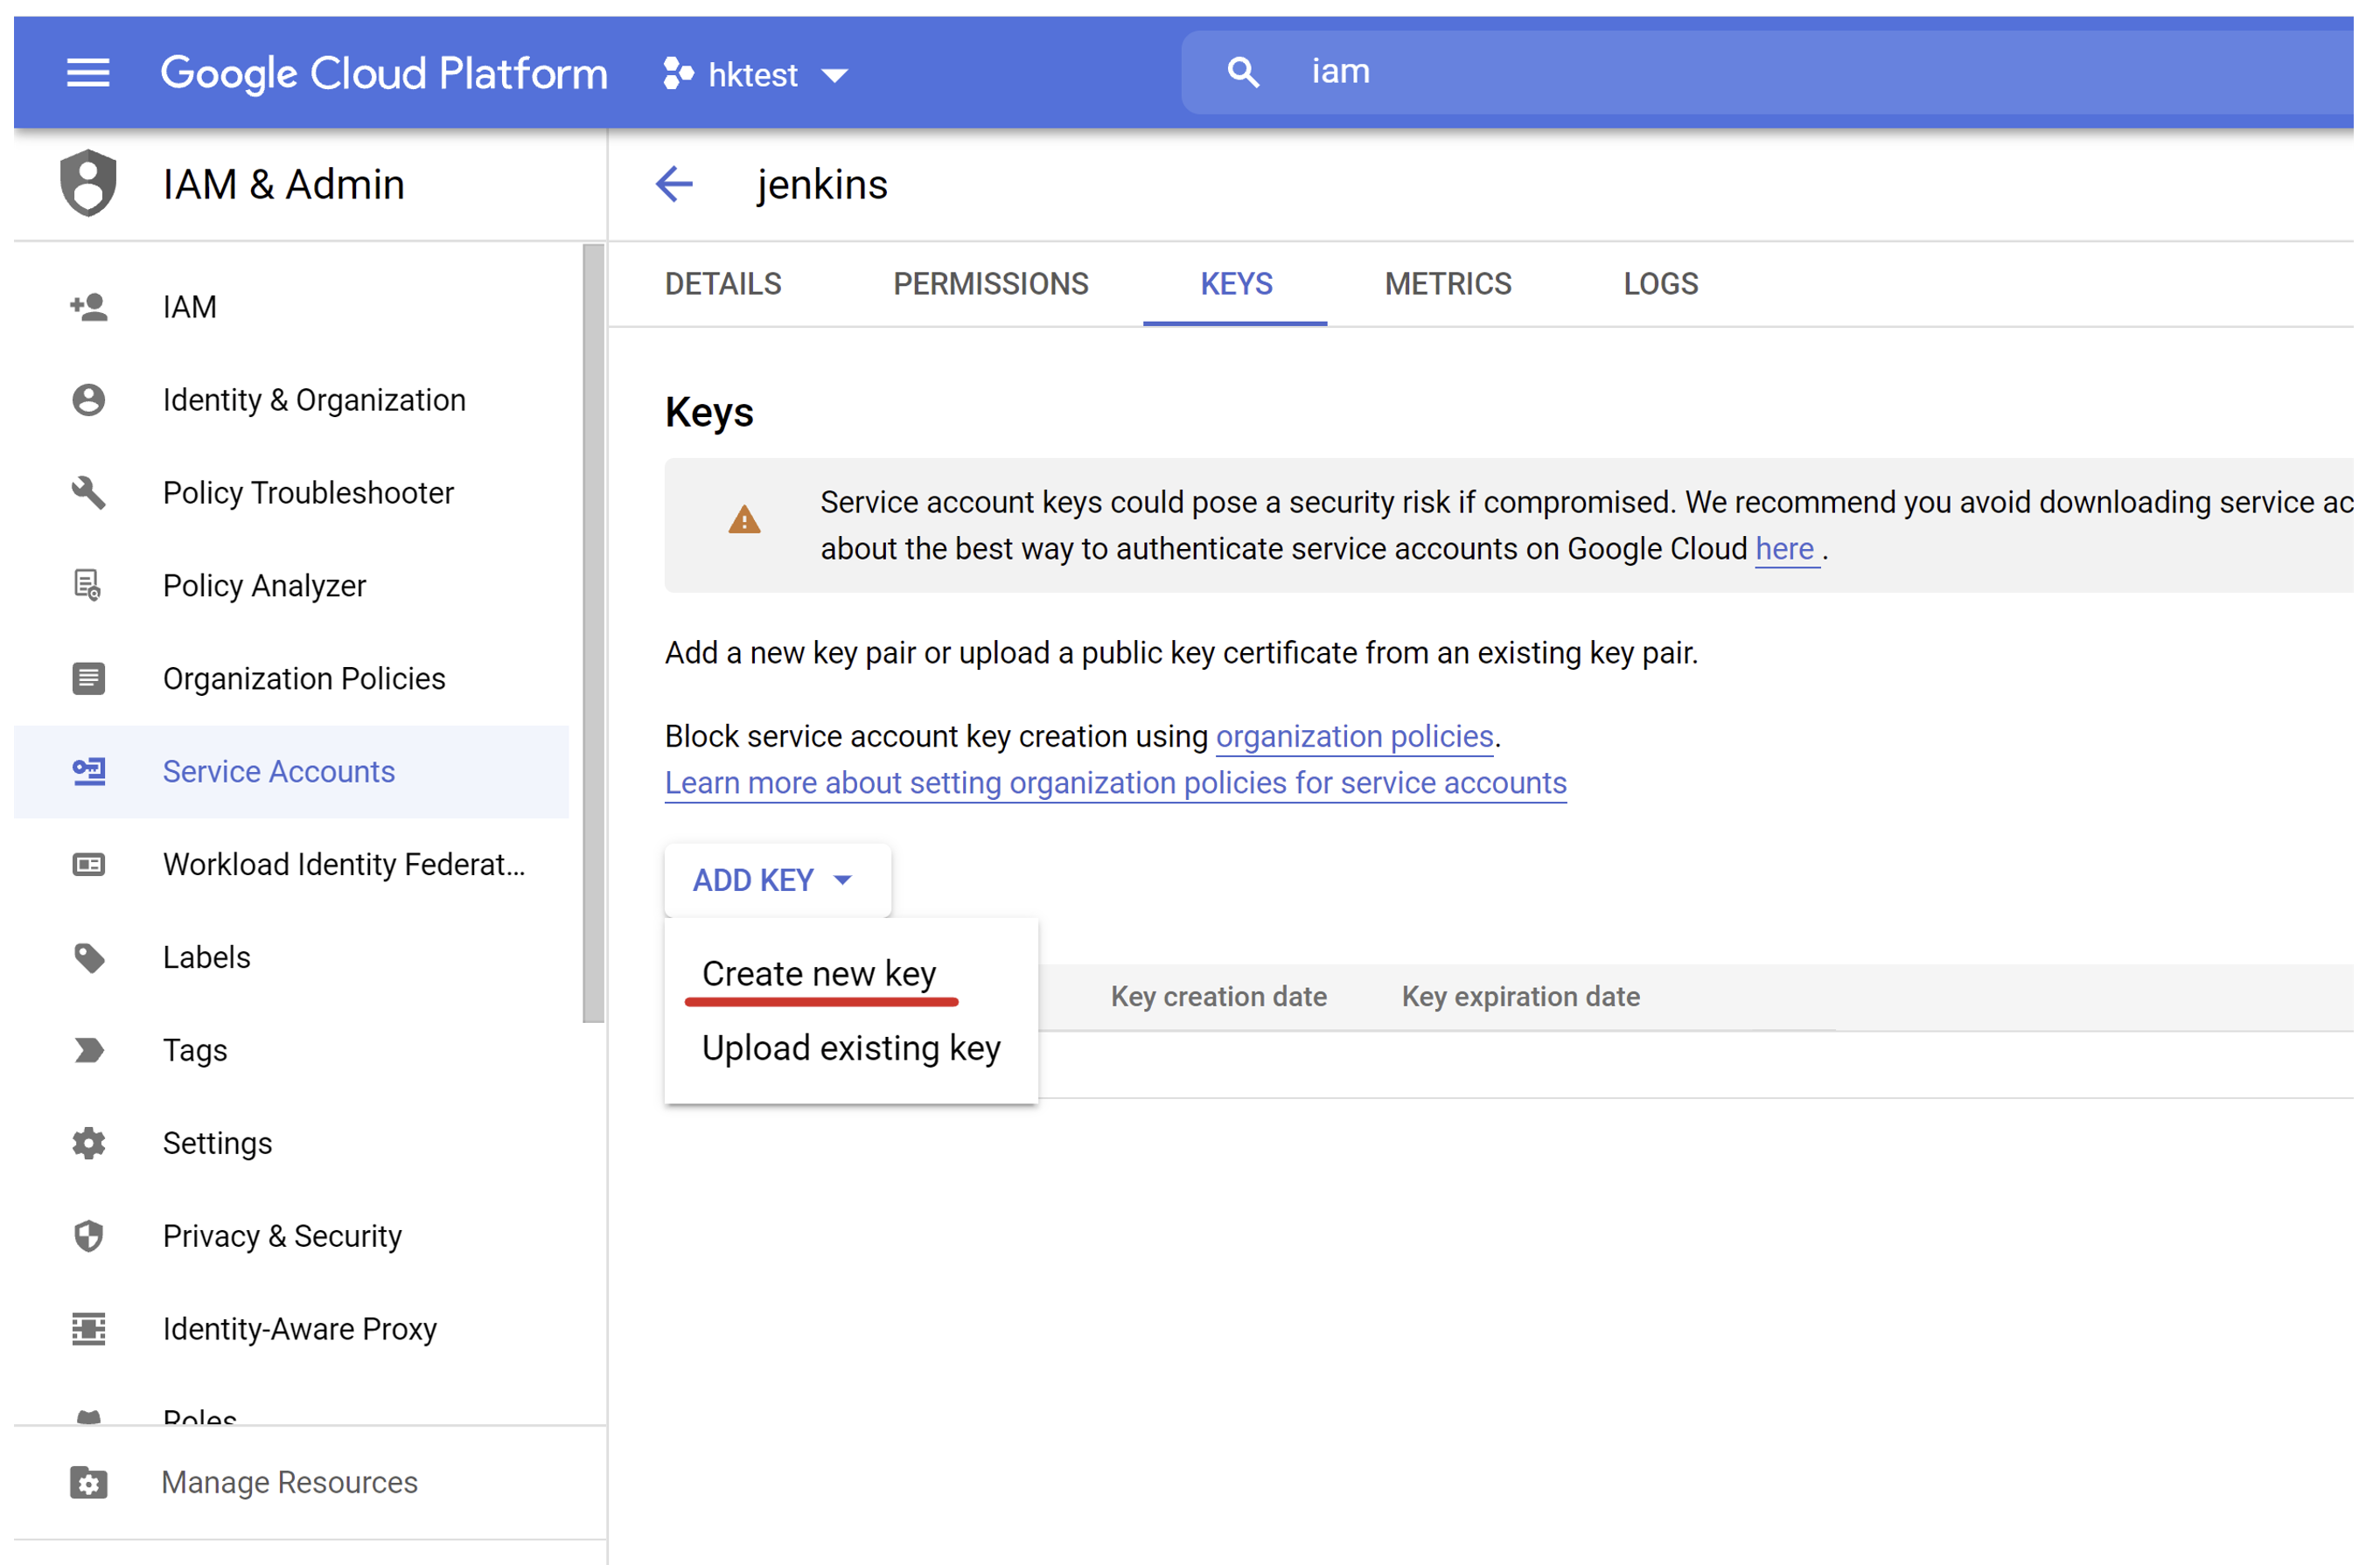

Select JSON key option to create and download new JSON credentials file. Such a file can be uploaded to a Jenkins server and used by Jenkins to access your GCP project and push Docker images into your GCP Container Registry.



Your web browser should download service account key to your desktop. Keep in mind that this is secret file and anybody who got access to it can use it to access your GCP Container Registry. Keep it safe and secure!

# Google Container Registry service

## Contents

* [Overview](https://qa-community.co.uk/~/_/learning/lbg-gcp/gcp--gcr#overview)
  + [Containers and API compatibility](https://qa-community.co.uk/~/_/learning/lbg-gcp/gcp--gcr#containers-and-api-compatibility)
* [Tutorial](https://qa-community.co.uk/~/_/learning/lbg-gcp/gcp--gcr#tutorial)
* [Exercises](https://qa-community.co.uk/~/_/learning/lbg-gcp/gcp--gcr#exercises)

## Overview

Google Container Registry service, or GCR for short, is a highly available Container registry service from Google Cloud Platform. GCR is a great choice if you are running your containerised applications in GCP and you need a secure and scalable registry for hosting your container images.

### Containers and API compatibility

GCR service is compatible with Docker API. It supports container images in the following formats:

* Docker Image Manifest V2
* OCI

In practice, it means that any existing Docker client can access the Google Container Registry service without any issues. The experience will be very similar to using DockerHub.

## Tutorial

Let's try to demonstrate how to use an image registry from the GCP to host your container images. First of all, open the GCR service in the Google Cloud Console. You will find it in the "CI/CD" section of the services list.

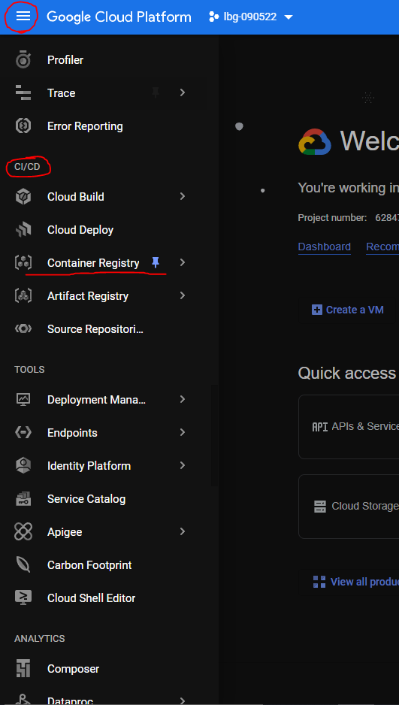

After clicking the "Container Registry" button you should see an empty registry page.

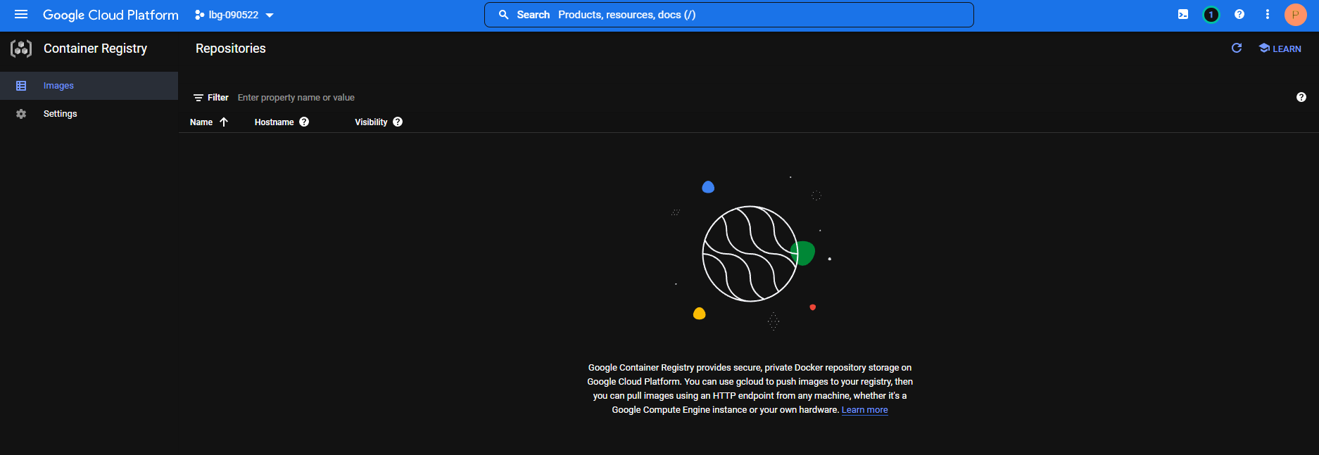

It is empty because we have not added any images there yet. Let's change it! Open Google Cloud Shell window.

You may be asked by Google Shell to authorize as soon as you execute any command in your shell. In such a case, just click the blue "Authorise" button.

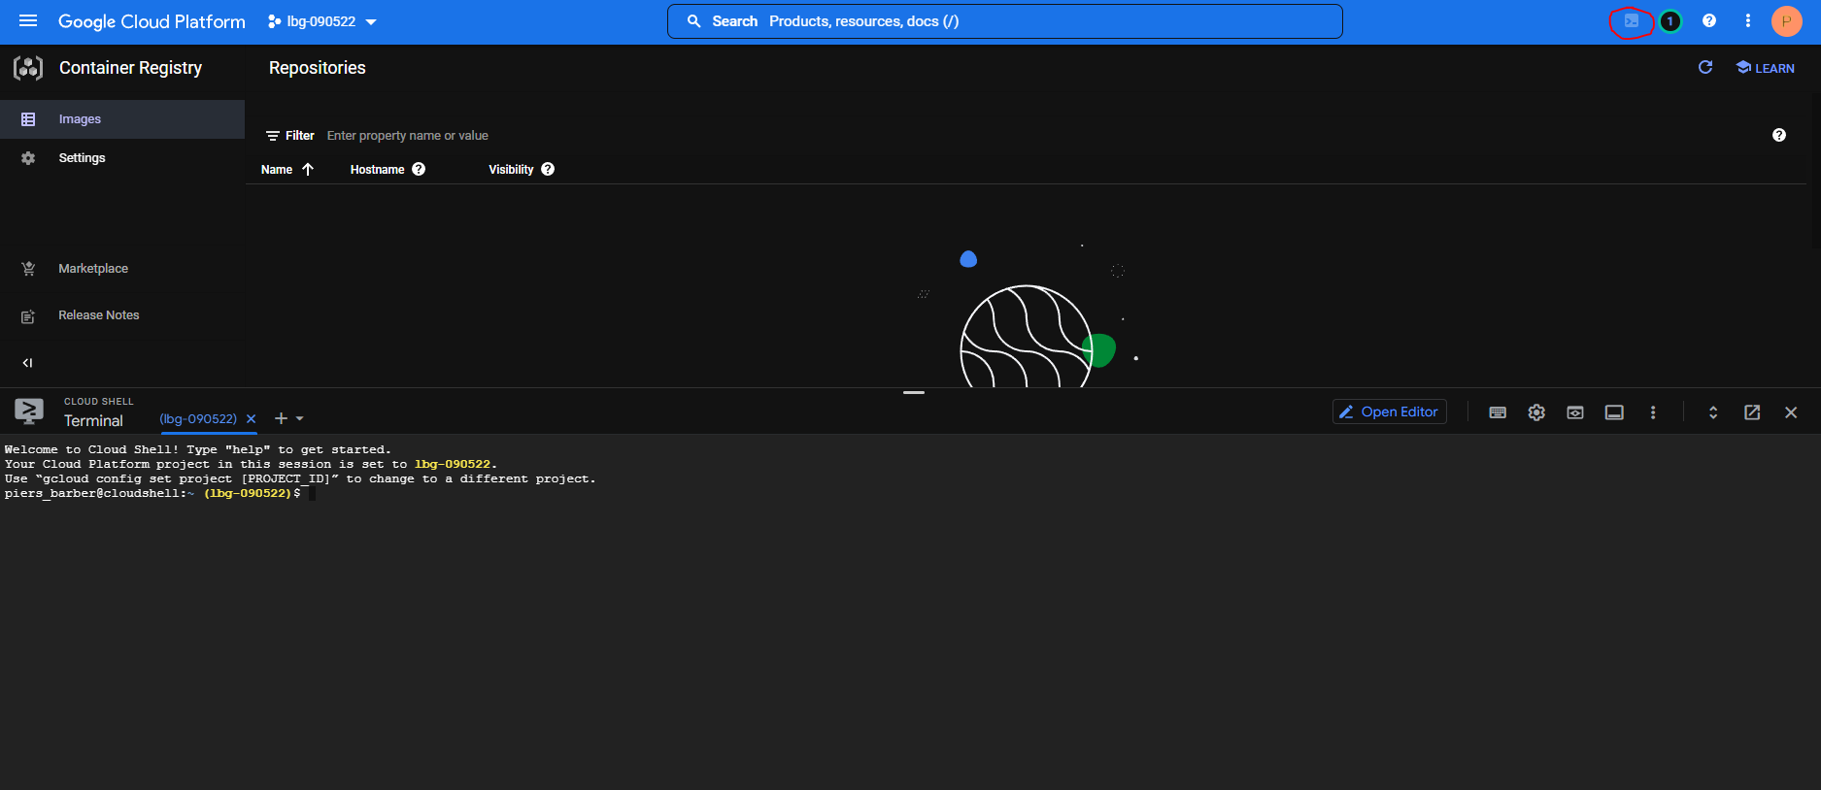

Now we will create a new Docker image from a scratch and push it into GCR. Start by creating a new directory in the Google Cloud Shell.

mkdir hello

Now navigate to this new directory.

cd hello

As a next step, create a file named Dockerfile with the following content:

touch Dockerfile

nano Dockerfile

**FROM** ubuntu

**RUN** echo 'Hello world!' > /tmp/hello.txt

**ENTRYPOINT** ["cat", "/tmp/hello.txt"]

The Dockerfile above defines a container image that uses Ubuntu Linux as a base and reads Hello world! message from a file.

Now build a Docker image named hello locally, by executing the docker build . -t hello command:

docker **build** -t hello .

You can quickly verify if the container image was created successfully:

docker run -**it** hello

As you can see our container prints a welcome message "Hello World!" as we expected.

Now let's try to push our image into GCR! As a first step, you need to tag your image to indicate that it is supposed to be stored in GCR. You can do it using the following command:

docker **tag** **hello** gcr.io/YOUR-GCP-PROJECT-NAME/hello:v1

The tag above indicates that your local hello image should live in GCR in your GCP project. We also assigned version v1 to our image.

Now execute the command docker push gcr.io/YOUR-GCP-PROJECT-NAME/hello:v1 to push our image into GCR.

$ docker push gcr.io/YOUR-GCP-PROJECT-NAME/hello:v1

The push refers to repository [gcr.io/YOUR-GCP-PROJECT-NAME/hello]

46835fde2631: Pushed

7555a8182c42: Layer already exists

v1: digest: sha256:3c1df0a974520421ed32ae26ef45a607be329391c9ae7e1a01c28a6b649b76ee size: 736

After pushing your image, hit the "Refresh" icon in the GCR console to see the results:

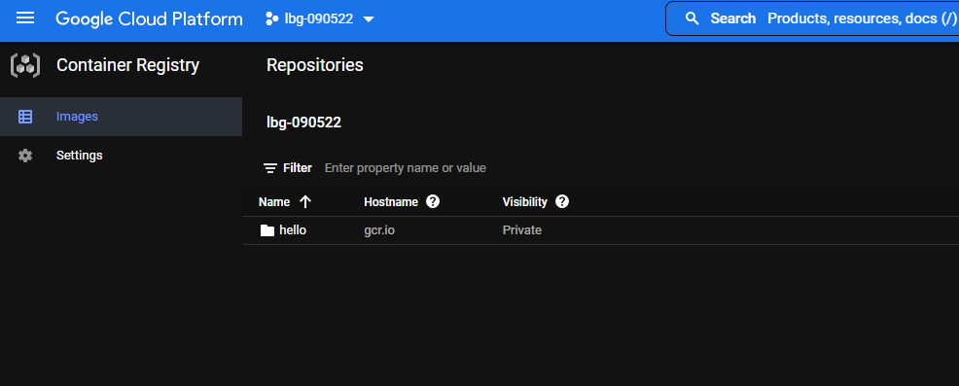

As you can see GCR has a dedicated folder for our hello image now.

Inside the hello folder you can see our v1 container image we have just pushed from Google Shell.

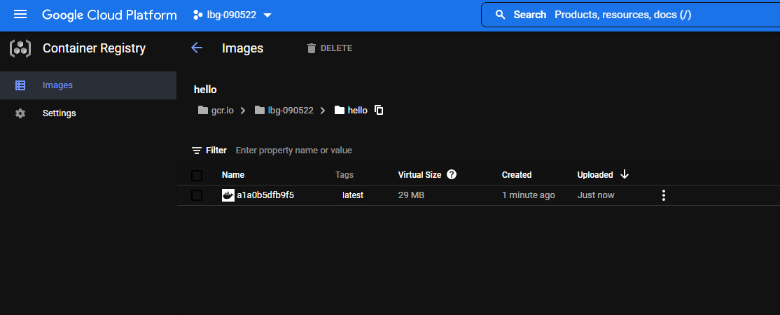

Now imagine that your coworker would like to run this image on their local machine with Docker and gcloud installed on it. They could just try to run the docker run -it gcr.io/YOUR-GCP-PROJECT-NAME/hello:v1 command, but they will see a message similar to the one below.

$ docker run -it gcr.io/YOUR-GCP-PROJECT-NAME/hello:v1

Unable **to** find image 'gcr.io/YOUR-GCP-PROJECT-NAME/hello:v1' locally

docker: Error response **from** daemon: pull access denied **for** gcr.io/YOUR-GCP-PROJECT-NAME/hello, repository does **not** exist **or** may require 'docker login': denied: Permission denied **for** "v1" **from** request "/v2/YOUR-GCP-PROJECT-NAME/hello/manifests/v1".

See 'docker run --help'.

It is because they have to authenticate to GCR before downloading the image. If they share the same GCP project with you, they can just use the gcloud auth configure-docker command to authenticate against GCR.

$ gcloud auth configure-docker

Adding credentials **for** **all** GCR repositories.

WARNING: A long list **of** credential helpers may cause delays running 'docker build'. We recommend **passing** the registry **name** **to** configure **only** the registry you are **using**.

**After** **update**, the **following** will be written **to** your Docker config file

located at [/home/hekonsek/.docker/config.json]:

{

"credHelpers": {

"gcr.io": "gcloud",

"us.gcr.io": "gcloud",

"eu.gcr.io": "gcloud",

"asia.gcr.io": "gcloud",

"staging-k8s.gcr.io": "gcloud",

"marketplace.gcr.io": "gcloud"

}

}

**Do** you want **to** **continue** (Y/n)?

Docker **configuration** file updated.

After successful authentication, your coworker can execute a container created from the image you published without any issues.

$ docker run -**it** gcr.io/YOUR-GCP-PROJECT-NAME/hello:v1

Hello world!